E2: Risks to physical assets of businesses

Summary vulnerability assessment
This report forms part of the West Yorkshire Combined Authority Climate Risk and Vulnerability Assessment and examines risks to the physical assets of businesses. Flooding can damage premises, equipment and stock, while heat can reduce building usability and damage goods; storms and water scarcity add further risks. Exposure is rated high: 49% of mapped commercial land parcels overlap areas with a medium or high future likelihood of river or surface-water flooding, and 53% have some exposure to medium or high relative surface heat. These measures indicate potential exposure, not damage to individual buildings. Sensitivity is significant because damage, restricted access, higher operating costs and reduced asset values could cause substantial disruption, especially for smaller businesses. Adaptive capacity is significant: flood-management programmes, local plans and business networks provide support, but business participation is limited and adaptation to heat remains uneven. Overall vulnerability is rated high.
3
High
2
Significant
2
Significant
3
High
Exposure
Sensitivity
Adaptive Capacity
Overall Vulnerability

Risk summary
Climate hazards can damage business premises, equipment, stock and other fixed assets. They can also make buildings less usable, interrupt access and operations, increase cooling and insurance costs, and reduce asset values. Flooding currently has the strongest evidence base, but risks from extreme heat, storms, drought and water scarcity are expected to increase. The national Climate Change Risk Assessment (CCRA4) identifies this risk as requiring critical action.,

Exposure: How exposed is the West Yorkshire region to this risk?
High
Exposure

A separate flood mapping analysis conducted for this assessment indicates widespread potential exposure of commercial assets to flooding and high surface temperatures. Around 15,982 commercial land parcels, 49% of those mapped, overlap areas with a medium or high future likelihood of river or surface-water flooding. Combined Authority reporting similarly identifies around 15,000 commercial properties within flood zones. Exposure is particularly high for industrial or manufacturing parcels, at 74%, and distribution or storage parcels, at 70%. The number of land parcels with medium to high exposure to flooding for the commercial sector is summarised in Table 1.
Table 1: Number of land parcels with some exposure to medium or high surface heat in West Yorkshire, by Local Authority and OS Land use type
Land use categories | Bradford | Calderdale | Kirklees | Leeds | Wakefield | Total
Attraction Or Activity | 115 | 23 | 79 | 120 | 47 | 384
Commercial Activity: Animal Services | 5 | 6 | 3 | 9 | 5 | 28
Commercial Activity: Distribution Or Storage | 250 | 40 | 127 | 359 | 78 | 854
Commercial Activity: Industrial Or Manufacturing | 178 | 19 | 36 | 68 | 25 | 326
Commercial Activity: Other | 2,028 | 799 | 1,342 | 2,995 | 1,210 | 8,374
Commercial Activity: Retail | 1,659 | 765 | 1,466 | 2,168 | 899 | 6,957
Construction | 15 | 2 | 9 | 40 | 10 | 76
Temporary Or Holiday Accommodation | 27 | 3 | 11 | 22 | 7 | 70
Total Commercial | 4,277 | 1,657 | 3,073 | 5,781 | 2,281 | 17,069

A separate heat mapping analysis carried out for this assessment found that 17,069 commercial parcels, 53% of those mapped, have some exposure to medium or high relative surface heat. The proportion varies by local authority, from 63% in Bradford to 42% in Calderdale. Distribution and storage, retail, and industrial or manufacturing land uses have particularly high exposure. The mapping measures daytime land-surface temperature rather than air temperature or indoor overheating, so it indicates potential exposure rather than building-level risk.
Local business testimony supports these spatial findings. Interviewees describes recurring impacts on businesses in valley-bottom locations, including businesses in Hebden Bridge that have experienced flooding, reinstatement and subsequent flooding. They also identify Calderdale, Keighley, Airedale, parts of Bradford and areas close to watercourses as locations of concern. Local business sector contributions to this assessment also noted examples of rented commercial premises flooding every few years, disruption to access where buildings themselves remained undamaged, and an industrial storage unit becoming hot enough for stored timber to warp. Whilst anecdotal, from professional experience, these examples show how mapped exposure can translate into damage, restricted access and financial loss.

Sensitivity: How significant could this risk be for the West Yorkshire region?
Significant
Sensitivity

Physical damage and declining building usability could cause substantial, but not necessarily catastrophic, consequences for affected businesses and local economies.
Flooding can damage buildings, equipment, electrical systems and stock. It can also obstruct roads and access, interrupt production, increase reinstatement costs and lead tenants to seek lower rents or alternative premises. West Yorkshire business sector representatives identified cases where repeated flooding and weak landlord incentives could leave commercial properties at risk of becoming stranded assets, meaning assets that lose value or become difficult to use.10 Contributors emphasised that a building can remain structurally intact while becoming inaccessible, uninsurable or unsuitable for continued business use.
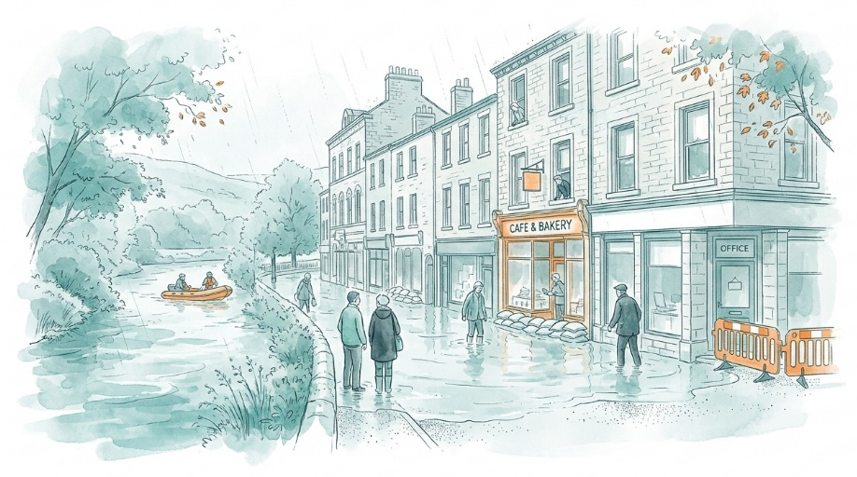
Heat can damage goods, reduce the usability of offices and industrial premises, increase mechanical cooling requirements and affect workplace comfort and productivity. West Yorkshire business representatives agreed that overheating is already material in offices, education buildings and storage premises.10 They also highlighted the interaction between cooling, ventilation, noise and air pollution, showing that opening windows may transfer rather than resolve the problem.
The national climate change risk assessment finds that risks extend beyond direct physical damage.3 Assets in exposed places may have shorter useful lives, higher operating and insurance costs, reduced marketability and lower values. It also identifies water scarcity as a growing concern for water-dependent sectors such as manufacturing, data centres, energy generation and low-carbon hydrogen production.
Small and medium-sized enterprises may be particularly sensitive where they have limited finance, management time or alternative premises. A West Yorkshire key stakeholder interviewee described a predominantly small and medium-sized enterprise business base facing overlapping cost and management pressures.9 They suggested that businesses directly affected by flooding recognise the risk, but those further removed may not connect operating pressures with climate hazards. They also identified shortages in heating, ventilation and air-conditioning skills as a potential factor increasing the cost of adapting to heat.
The regional spatial vulnerability analysis conducted for this assessment indicates that vulnerability is not uniform. The average Neighbourhood Business Vulnerability Index is above the England average in Kirklees and Calderdale, but below it in Leeds, Bradford and Wakefield.

Adaptive Capacity: Existing programmes, plans, policies, budgets and community action
Significant
Adaptive Capacity
Relevant policies, programmes, business networks and flood-management arrangements exist, but action is uneven and important gaps remain.
The West Yorkshire Climate and Environment Plan commits the West Yorkshire Combined Authority and partners to enhanced flood protection, natural flood management and collaboration on water management.
A November 2024 programme update reported:
- an indicative £7.07 million Natural Flood Management programme;
- an initial indicative allocation of up to £10 million for the Capital Flood Risk Management programme, with £5.65 million approved for project expenditure at that point; and
- a £5 million West Yorkshire Property Flood Resilience programme intended to support 100 small and medium-sized enterprises.
Early business participation in the property resilience programme was limited. At the reporting date, 18 enquiries and three approved survey applications had been received, while no applications had been received for capital grants. The report also explained that individual projects were not guaranteed funding until full business-case approval.
A July 2026 Investment Board decision shows that flood-risk investment is continuing, but also illustrates delivery constraints. The Board extended the Brighouse Flood Alleviation Scheme Phase 1 timescale to March 2028 and removed the Phoenix Bridge element from its scope.
The Aire Resilience Company provides a business-supported model for natural flood management in the Aire Valley. It brings businesses, farmers and landowners together to fund measures intended to complement the Leeds Flood Alleviation Scheme.
Local strategies and partnerships add capacity. Kirklees has a 2024 Local Flood Risk Management Strategy covering adaptation, climate change, priority catchments and an action plan. Calderdale’s flood action work includes defences, drainage, natural flood management and infrastructure resilience. Bradford and Leeds maintain strategic flood-risk assessments to support planning and development decisions., West Yorkshire Prepared also maintains multi-agency arrangements for severe weather and flooding, including warnings, preparedness advice and business-continuity messages.
Business networks provide skills and communication capacity. Business stakeholders describe the Chamber’s role as connecting businesses with solutions and translating policy into practical language.10 They identify existing knowledge-transfer networks and businesses developing flood protection, water management, energy efficiency and other adaptation services. However, they report limited management capacity among small businesses and argues that business support is often fragmented by policy theme rather than presented as an integrated response to operational needs.
Capacity for adapting commercial buildings to heat is less established than flood capacity. Key business sector stakeholders identified examples of improved modelling, mechanical ventilation, environmental controls, sustainable drainage and nature-based design.9 Nevertheless, they judged overall progress to be uneven and too dependent on individual clients or commercial incentives. Reported barriers include short payback horizons, landlord-tenant split incentives, fragmented ownership, minimum standards, value engineering, limited user information and the difficulty of adapting existing buildings.
Nationally, the Climate Change Risk Assessment 4 identifies uneven business preparedness.3 It reports that many firms have not assessed relevant climate risks and that adaptation by small and medium-sized enterprises is constrained by financial and information barriers. It concludes that existing adaptation does not adequately address the rising risk, supporting its recommendation for critical action.
The significant score reflects established flood-management institutions, investment programmes, local plans and active business networks. A high score is not supported because business participation remains limited, heat adaptation is not systematic, measures can be weakened by commercial and ownership barriers, and outcomes are not consistently monitored.

Annex: Scoring Matrix
The scoring methodology uses the following formula to calculate overall vulnerability for each risk/opportunity area.
Exposure
Sensitivity
Adaptive Capacity
Overall Vulnerability
Exposure, sensitivity and adaptive capacity are scored on a scale of 0-3 (see below).

Exposure
The presence of people, livelihoods, species or ecosystems, environmental functions, services, and resources, infrastructure, or economic, social, or cultural assets in places and settings that could be adversely affected.
Score | Rating | Description | Area or System exposed
3 | High | 50-100% of affected area/system expose to climate hazards | 50-100%
2 | Significant | 25-50% of affected area/system expose to climate hazards | 25-50%
1 | Moderate | 10-25% of affected area/system expose to climate hazards | 10-25%
0 | Low or None | 0-10% of affected area/system expose to climate hazards | 0-10%

Sensitivity
The degree to which a system or species is adversely or beneficially affected by climate variability or climate change.

Score | Rating | Description
3 | High sensitivity | Potential loss of life or high impact caused by climate change. Difficult or impossible for systems to recover
2 | Significant sensitivity | If climate changes event happens, high impact, but not catastrophic
1 | Moderate sensitivity | If climate changes event happens, there is an impact, but not very disruptive
0 | None or low sensitivity | Limited or no consequence from climate event

Adaptive Capacity
The ability of current systems, institutions, structural units, humans and other organisms to adjust to potential damage, to take advantage of opportunities, or to respond to consequences
Score | Rating | Description
0 | Low or No Adaptive Capacity | Limited or no local or national policies or programmes in place to currently address specific risk/opportunity
1 | Moderate Adaptive Capacity | Either some local or national policies and programmes in place, that may indirectly address risk/opportunity or are limited in scope
2 | Significant Adaptive Capacity | Either local or national policies and programmes in place specifically addressing risk, but there are still gaps
3 | High Adaptive Capacity | Well established systems (policies, programmes) that are currently addressing this risk

Vulnerability
The final vulnerability score is calculated by adding the exposure and sensitivity scores, then subtracting the adaptive capacity score. Vulnerability is then categorised from Very High to Very Low depending on the final score.
Score | Rating
Very High | Total Score between 5 & 6
High | Total Score between 3 & 4
Medium | Total Score between 1 & 2
Low | Total Score between -1 & 0
Very Low | Total Score between -3 & -2

The detailed scoring matrix is provided in Annex: Scoring Matrix.
Local Authority Climate Report | West Yorkshire
CCRA4 Technical Report | Risks to Economy (2026)
The National CCRA risk has a broader focus that includes business assets in the UK and overseas
Flood Exposure Assessment for the West Yorkshire Climate Risk Assessment (2026)
West Yorkshire Combined Authority, Flood Resilience Programmes Update, November 2024
These figures identify parcels with some overlap and do not mean that every building, or the whole of each parcel, would flood
Heat Exposure Assessment for the West Yorkshire Combined Authority (2026)
Key stakeholder interview 04 September 2026, facilitated for the West Yorkshire Climate Risk Assessment
West Yorkshire Business Sector Discussion Group, 22 September 2026, facilitated for the West Yorkshire Climate Risk Assessment
Spatial Indicators of Vulnerability in the West Yorkshire Combined Authority (2026)
West Yorkshire Climate and Environment Plan (2025 - 2038)
West Yorkshire Combined Authority Flood Resilience Programmes Update (2024)
Flood Resilience Programmes Update
Aire Resilience Company
Kirklees Local Flood Risk Management Strategy (2024)
How We’re Reducing the Risk of Flooding for Calderdale | Environment Agency
Bradford District Strategic Flood Risk Assessment (2023)
Leeds Local Flood Risk Management Strategy
West Yorkshire Prepared, Community Risk Register (2025)

