H1: Risks to people from heat

Summary vulnerability assessment
This report forms part of the West Yorkshire Combined Authority Climate Risk and Vulnerability Assessment and examines risks to people from heat in the region.
Extreme heat can cause death and serious illness across West Yorkshire, with risks concentrated among older people, young children, pregnant people, people with existing health conditions, people experiencing deprivation and those living or working in buildings and neighbourhoods that retain heat.
Heat-alert systems, organisational plans and local public-health activity provide some capacity to respond, but available evidence does not show a consistent, funded and tested heat-adaptation system across all five districts.
The resulting overall vulnerability rating is high. The figure below summarises the assessment scores for exposure, sensitivity, adaptive capacity and overall vulnerability.
1
Moderate
3
High
1
Moderate
3
High
Exposure
Sensitivity
Adaptive Capacity
Overall Vulnerability

Risk summary
Extreme heat threatens health and wellbeing by causing heat exhaustion, heatstroke and dehydration, and by worsening cardiovascular, respiratory, renal, neurological and mental health conditions. It can also disrupt sleep, affect medication, restrict physical activity and reduce people’s capacity to work. The Fourth Climate Change Risk Assessment (CCRA4) rates the current and future risk for England as very high and identifies older people, young children, pregnant people, people with existing health conditions, outdoor workers, urban residents and people experiencing deprivation as particularly vulnerable.
Recent monitoring shows that severe impacts are already occurring. UKHSA provisionally estimated 2,877 heat-associated deaths in England during the May and June 2026 heat episodes. The risk will increase as heatwaves become more frequent and intense, cities retain more heat and the population ages. CCRA4 projects UK heat-related deaths of 1,500 to 4,000 a year in the 2030s and 3,800 to 10,000 in the 2050s under high-warming scenarios, before allowing for population change or additional adaptation. Yorkshire is identified among the English regions facing higher future risk.²

Exposure: How exposed is the West Yorkshire region to this risk?
Moderate
Exposure

There is no localised spatial mapping data on heat risk in the UK. A separate heat exposure assessment for the West Yorkshire Combined Authority did however show that heat risk for residents is common. The assessment found that 20.3% of residential land parcels have some overlap with medium or high surface-heat bands. Residential land also has the largest number of exposed parcels, at 186,275. Exposure is higher among commercial land at 52.8%, medical sites at 39.7%, education sites at 39.5% and transport sites at 37.0%.
The map in Figure 1 (based on the same assessment) shows the highest temperature bands concentrated around central Leeds and parts of Bradford. Smaller pockets also appear around Wakefield, Calderdale and Kirklees. Low and very low temperature bands are more widespread outside these clusters.
Table 1: Summary of land parcels with some exposure to medium or high surface heat in West Yorkshire, by CRVA theme. Source: Heat Exposure Assessment for the West Yorkshire Combined Authority (2026)
Land type category | Number of parcels exposed | Percentage of parcels exposed
Commercial | 17,069 | 52.8%
Community Services | 1762 | 25.7%
Education | 592 | 39.5%
Medical | 425 | 39.7%
Residential | 186,275 | 20.3%
Services | 2,219 | 24.5%
Transport | 404 | 37.0%

Heat exposure across the combined authority is therefore concentrated in built-up areas with dense buildings, paved surfaces and limited vegetation. National urban modelling confirms this common urban heat island effect, where towns and cities are warmer than surrounding rural areas.
Local sources do however show variation within the region:
- In Bradford, local analysis estimates that 384,050 people living in the district’s most densely populated areas are more exposed to higher temperatures. It identifies 37 neighbourhoods with high heat and enhanced vulnerability.
- In Wakefield, 19 of 45 neighbourhood areas were identified as having high heat and enhanced risk, containing 45% of the district’s population. These locations are concentrated around Wakefield city and the north-east and south-east of the district.
- Stakeholders in Leeds reported overheating in dense neighbourhoods including Harehills, Chapeltown, Beeston and Seacroft. Reported contributing factors included closely spaced terraced housing, high-rise homes, overcrowding, limited gardens and restricted control over rented accommodation.
- Health-sector stakeholders reported heat exposure in wards, clinics, ambulances and community settings. However, there is no complete regional inventory of exposed care homes, schools, workplaces, community buildings, health sites or neighbourhoods.
Urban exposure also has economic consequences. National modelling estimates that Yorkshire and the Humber lost 580,000 working hours and £29 million in Gross Value Added during the extreme heat conditions represented by 2022.⁶ Under its central scenario, losses rise to 3 million hours and £170 million in an extreme year in the 2050s. However, these are Yorkshire wide figures and cannot be assigned specifically to West Yorkshire.

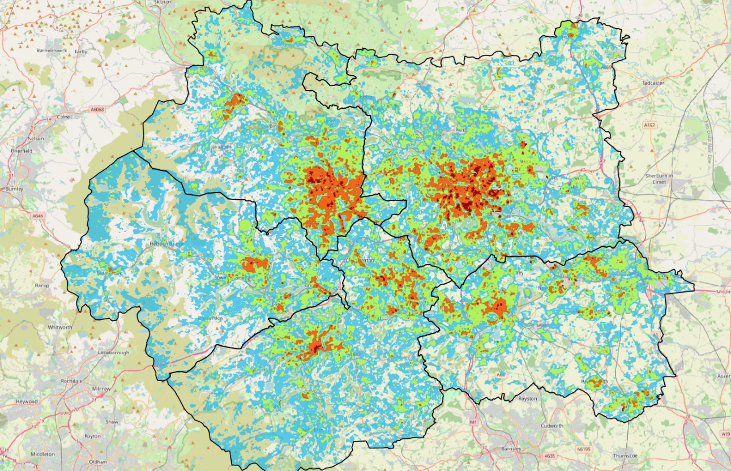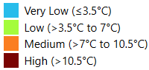
Figure 1: Surface Urban Heat Index Map for West Yorkshire Combined Authority showing temperature bands

Sensitivity: How significant could this risk be for the West Yorkshire region?
High
Sensitivity
Extreme heat can cause death and severe illness, as detailed in the national CCRA4 which identifies strong evidence for all-cause mortality and growing evidence for cardiovascular, renal, respiratory, dementia and acute mental health outcomes.² The national CCRA also highlights increased health-service use during hot weather, including additional general practice consultations, prescriptions, accident and emergency attendances and hospital admissions in England.
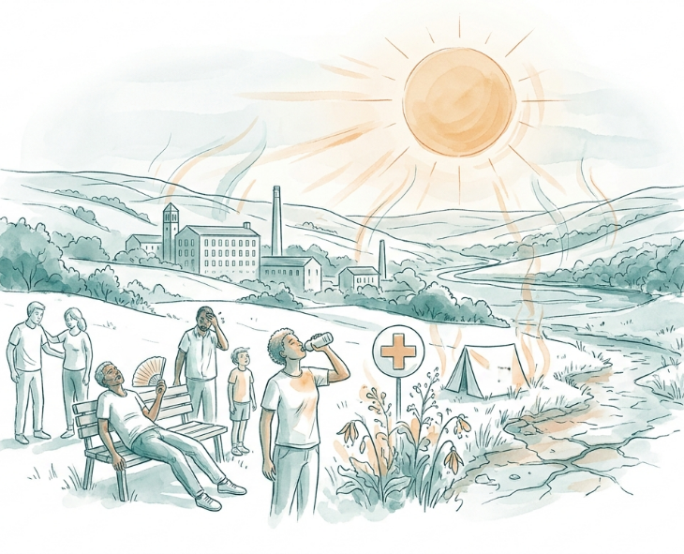
National urban modelling provides further evidence of the potential magnitude. In an extreme year, the estimate for Yorkshire and the Humber rises from 140 heat-related deaths in the 2022 baseline to 210 in the 2030s and 430 in the 2050s under a central scenario.⁶ Most projected deaths are among people aged 75 and over. These modelled figures cover the whole Yorkshire region and should not be interpreted as West Yorkshire forecasts.
Sensitivity is shaped by overlapping health, housing and socioeconomic factors. Across the Combined Authority area, 7.75% of residents are aged 75 or over, 7.78% report disability or ill health that limits daily activities a lot, 10.32% receive home-based care and 13.71% of households include someone with long-term ill health. Local authority averages may hide much greater differences between neighbourhoods. People may be more sensitive where poor health coincides with housing that overheats, deprivation, limited access to green space or an inability to pay for cooling.
Health-sector stakeholders consulted for this assessment reported increased emergency calls, heatstroke and dehydration, hot wards, disturbed sleep, staff fatigue and risks to medicines, diagnostic equipment, information technology and vehicle cooling. They identified particular concerns for people experiencing homelessness, people living in high-rise housing, people without nearby green space and patients receiving care in hot buildings or vehicles.¹⁰
Community interviews described homes becoming too hot to remain indoors, people staying outside late into the evening, community buildings without adequate cooling, social isolation among people trying to remain in shaded rooms and limited options for private renters. These accounts illustrate the interaction between heat, housing and inequality, but they do not establish how widespread each experience is in the region.⁹
Sensitivity is also affected by household agency. Community representatives emphasised to this assessment that some of the people most exposed to overheating may have the least control over their homes, including renters and households with limited resources.¹²
Community stakeholders also described heat as compounding existing respiratory and air-quality vulnerability. Participants referred to people with asthma and other respiratory conditions living near major roads in Bradford experiencing greater difficulty during hot, still conditions.
“With extreme heat me and my friends were unable to focus and be productive.”
Climate stories submitted by the public to this assessment during August and September 2026 illustrate how heat is affecting everyday settings across the region. Contributors described a Wakefield charity office becoming unusable above 26°C, students struggling to concentrate in hot housing in Leeds, children with special educational and medical needs experiencing difficulties in overheated classrooms, and older passengers and volunteers cancelling community transport journeys during hot weather in Ilkley.

Adaptive Capacity: Existing programmes, plans, policies, budgets and community action
Moderate
Adaptive Capacity

National, regional, organisational and community measures exist, but current evidence does not demonstrate a consistent, funded and tested heat-adaptation system across all five West Yorkshire districts.
National capacity includes the Adverse Weather and Health Plan 2026 to 2027, the Heat-Health Alert system and guidance for health, social care, public services and communities. The Local Authority Risk and Adaptation Toolkit: Heat Edition provides a framework covering leadership, care settings, homes, schools, homelessness, planning, occupations and infrastructure. However, the CCRA4 concludes that heat policy remains mostly reactive, public awareness is limited and evidence on the effectiveness of the Adverse Weather and Health Plan is lacking.²
Existing capacity within West Yorkshire includes:
- Yorkshire Ambulance Service Climate Adaptation Plan, alongside emergency preparedness and adverse-weather arrangements. It identifies actions concerning vulnerability mapping, estate assessment, cool areas, passive cooling, shade, trees, staff communication and workforce planning.
- Organisational adverse-weather plans, Emergency Preparedness, Resilience and Response arrangements, adaptation working groups, climate-risk assessments, draft heat-resilience plans, estate assessments and procedures for fans and coolers were reported by health-sector participants from a range of regional health related organisations.¹⁰
- Bradford’s public advice and heat resource pack, which identify possible actions including planning controls, urban greening, shade trees, water fountains, cool spaces and targeted communications.⁷
- Wakefield’s use of heat alerts, national action cards, resilience arrangements, public advice and its local heat and health evidence base.⁸
- Leeds’ public-health recommendations on heat-action planning, housing standards, green space and public awareness.
- Leeds has also moved beyond recommendations to pilot delivery. From June to September 2026, selected community hubs, libraries, leisure centres and neighbourhood networks operated as Cool Spaces, offering drinking water and places to rest and cool down.
Important regional constraints remain. Health-sector contributors reported limited capital budgets, maintenance backlogs, poorly monitored buildings, safety constraints and uncertainty about cost-effective interventions.¹⁰
Available evidence does not establish whether all identified actions are funded, implemented, tested or effective. There is no regional inventory of cooling infrastructure, cool spaces, community preparedness or capital investment needs. These gaps therefore support a moderate, rather than significant or high, adaptive-capacity score.

Annex: Scoring Matrix
The scoring methodology uses the following formula to calculate overall vulnerability for each risk/opportunity area.
Exposure
Sensitivity
Adaptive Capacity
Overall Vulnerability
Exposure, sensitivity and adaptive capacity are scored on a scale of 0-3 (see below).

Exposure
The presence of people, livelihoods, species or ecosystems, environmental functions, services, and resources, infrastructure, or economic, social, or cultural assets in places and settings that could be adversely affected.
Score | Rating | Description | Area or System exposed
3 | High | 50-100% of affected area/system expose to climate hazards | 50-100%
2 | Significant | 25-50% of affected area/system expose to climate hazards | 25-50%
1 | Moderate | 10-25% of affected area/system expose to climate hazards | 10-25%
0 | Low or None | 0-10% of affected area/system expose to climate hazards | 0-10%

Sensitivity
The degree to which a system or species is adversely or beneficially affected by climate variability or climate change.

Score | Rating | Description
3 | High sensitivity | Potential loss of life or high impact caused by climate change. Difficult or impossible for systems to recover
2 | Significant sensitivity | If climate changes event happens, high impact, but not catastrophic
1 | Moderate sensitivity | If climate changes event happens, there is an impact, but not very disruptive
0 | None or low sensitivity | Limited or no consequence from climate event

Adaptive Capacity
The ability of current systems, institutions, structural units, humans and other organisms to adjust to potential damage, to take advantage of opportunities, or to respond to consequences
Score | Rating | Description
0 | Low or No Adaptive Capacity | Limited or no local or national policies or programmes in place to currently address specific risk/opportunity
1 | Moderate Adaptive Capacity | Either some local or national policies and programmes in place, that may indirectly address risk/opportunity or are limited in scope
2 | Significant Adaptive Capacity | Either local or national policies and programmes in place specifically addressing risk, but there are still gaps
3 | High Adaptive Capacity | Well established systems (policies, programmes) that are currently addressing this risk

Vulnerability
The final vulnerability score is calculated by adding the exposure and sensitivity scores, then subtracting the adaptive capacity score.
Score | Rating
Very High | Total Score between 5 & 6
High | Total Score between 3 & 4
Medium | Total Score between 1 & 2
Low | Total Score between -1 & 0
Very Low | Total Score between -3 & -2

The detailed scoring matrix is provided in Annex: Scoring Matrix.
CCRA4 Technical Report | Risks to Health and Wellbeing (2026)
Interim Heat and Mortality Monitoring Report England, May and June 2026
Local Authority Climate Report | West Yorkshire
Heat Exposure Assessment for the West Yorkshire Combined Authority (2026)
These figures indicate relative land-surface heat exposure, rather than indoor overheating or the number of people at health risk
Heat risk and adaptation in the urban built environment | CCC & ARUP (2026)
Bradford Joint Strategic Needs Assessment, Heat and Health Harms Resource Pack (2026)
Wakefield Joint Strategic Needs Assessment, Heat and Health (2026)
Key stakeholder interviews carried out in August & September 2026, facilitated for the West Yorkshire Climate Risk Assessment
West Yorkshire Health Sector Stakeholder Focus Group, 7 September 2026, facilitated for the West Yorkshire Climate Risk Assessment
The national modelling represents West Yorkshire within the wider Yorkshire and the Humber climate region, it does not provide a separate mortality estimate for the Combined Authority.
Spatial Indicators of Vulnerability in the West Yorkshire Combined Authority (2026)
West Yorkshire Community Sector Webinar Discussion Group, 24 September 2026, facilitated for the West Yorkshire Climate Risk Assessment
Climate stories submitted through online survey
Adverse Weather and Health Plan 2026 - 2027
Local Authority Risk and Adaptation Toolkit Heat Edition
Yorkshire Ambulance Service NHS Trust, Climate Adaptation Plan 2024–2029
Leeds Director of Public Health Annual Report (2025)
Leeds Welcome / Cool Spaces

