H2: Risks to people from extreme weather, excluding heat

Summary vulnerability assessment
This report forms part of the West Yorkshire Combined Authority Climate Risk and Vulnerability Assessment and examines risks to people from extreme weather, excluding heat, which is addressed separately under H1. People and essential services across West Yorkshire face high exposure to flooding, storms, drought, wildfire and severe cold. Sensitivity is high because these events can cause loss of life, injury, illness, displacement, lasting mental-health effects and disruption to transport, utilities, healthcare and other essential services. Existing flood-risk management, emergency planning, health-system measures, utility resilience programmes and community action provide moderate adaptive capacity, but provision and preparedness remain uneven and important gaps persist.
The resulting overall vulnerability rating is very high. The figure below summarises the assessment scores for exposure, sensitivity, adaptive capacity and overall vulnerability.
3
High
3
High
1
Moderate
5
Very High
Exposure
Sensitivity
Adaptive Capacity
Overall Vulnerability

Risk summary
Flooding, storms, drought, wildfire and cold weather can cause injury, illness, deaths, displacement and long-term harm to mental wellbeing. They can also interrupt transport, electricity, water supplies and access to health and care. Nationally, flooding is the largest and best-evidenced growing health threat within this risk category, while evidence on the health effects of drought and wildfire remains less developed. Cold weather will continue to cause substantial harm, although it is not expected to increase because of climate change in the same way as the other hazards. The Fourth UK Climate Change Risk Assessment assesses the current and future combined UK risk as high and concludes that more action is needed.

Exposure: How exposed is the West Yorkshire region to this risk?
High
Exposure
Flooding is forecast to be widespread enough to expose people, homes and essential services in all five West Yorkshire districts, although exposure varies considerably between neighbourhoods and catchments. A separate regional flood exposure assessment combined both risks of flooding from surface water and risks of flooding from rivers and which land use types these flood risk zones were most common.
Table 1 summarises the key findings from the assessment. The table shows the number and percentage of land parcels with some exposure to medium or high climate change flooding across different types of land use. The results show that residential land has the largest number of exposed parcels, at 166,413, but the lowest percentage exposure, at 18.1%. Education, transport and commercial parcels have higher percentage exposure, at 71.0%, 57.8% and 49.4% respectively, but much smaller numbers of exposed parcels.

Table 1: Summary of land parcels with some exposure to medium or high climate change flooding in West Yorkshire, by CRVA theme
Land Parcel Categories | Number of parcels exposed | Percentage of parcels exposed
Commercial | 15,982 | 49.4%
Community Services | 2928 | 42.7%
Education | 1,064 | 71.0%
Medical | 462 | 43.1%
Residential | 166,413 | 18.1%
Services | 2,123 | 23.5%
Transport | 631 | 57.8%

Exposure is particularly apparent in the river valleys and rapidly responding catchments. Calderdale’s steep upland catchments channel runoff towards settlements in narrow valley bottoms, including Todmorden, Hebden Bridge, Mytholmroyd, Sowerby Bridge, Elland and Brighouse. Flooding is a regular feature there, with both river and surface-water incidents recorded already across the borough. In Leeds, many communities lie close to the Aire, Wharfe and their tributaries, while intense rainfall can also overwhelm surface-water drainage and sewers. Wakefield’s strategy similarly identifies exposure from rivers, ordinary watercourses, surface water, groundwater and sewers, alongside disruption to roads, utilities and services during past events.
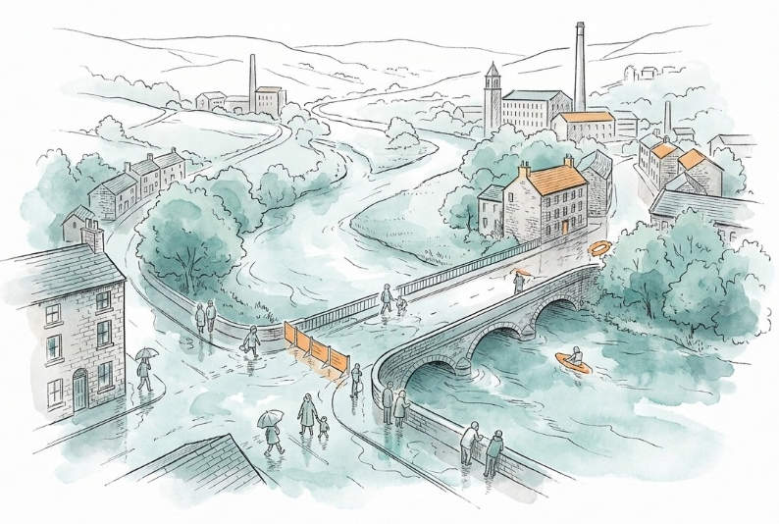
Community stakeholders also described flooding affecting homes, bridges and community facilities in the Aire Valley, with recurrent flash flooding and runoff reported in and around Shipley, Keighley and Silsden. They emphasised that local exposure is not confined to valley-bottom river flooding: intense rainfall can also channel water rapidly down urban streets and hillsides towards homes.
Other hazards have a less complete spatial evidence base. Local emergency-planning evidence identifies moorland wildfire exposure in western areas, more recent fire risk at the rural-urban edge, and greater cold-weather disruption in hillier western and north-western communities. It also stresses that exposure differs by hazard: flood-prone valley communities, isolated rural settlements and deprived urban neighbourhoods may each be vulnerable for different reasons.
Although each hazard affects different places, exposure to flooding, storms, drought, wildfire and severe cold extends across a large proportion of the region’s communities, supporting a high exposure score.

Sensitivity: How significant could this risk be for the West Yorkshire region?
High
Sensitivity
Extreme weather can threaten life and cause severe or lasting harm. Flooding can cause drowning, injury, contact with contaminated water, displacement and interruption of healthcare. Longer-term effects include anxiety, depression, post-traumatic stress, respiratory illness associated with damp and mould, financial strain and difficulty recovering from damage. National research found that mental-health impacts can persist for at least three years after flooding.
Local evidence shows how these effects can spread through essential services. Health-sector participants reported delayed ambulance and patient transport, road-access problems, cancelled or missed appointments, discharge difficulties, pressure on beds during prolonged cold weather and concerns about power loss. Community evidence also identified less visible disruption to everyday mobility.⁸ Participants described deep standing water on pavements preventing people with children or prams from passing and argued that walking routes, greenways and public spaces should be considered alongside roads when assessing the effects of intense rainfall.
The local evidence is strongest for flooding, transport and electricity disruption; it does not provide a complete inventory of exposed facilities or consistent evidence on wildfire impacts. Yorkshire Ambulance Service also reports that more than 10% of the Yorkshire Ambulance Service estate is at risk of flooding and identifies risks to service access, buildings, vehicles, infrastructure and supply chains from flooding and adverse weather.
Sensitivity is unevenly distributed. Young children, older people, people with disabilities or long-term health conditions, people receiving care at home and households with limited income may have greater difficulty preparing, evacuating or recovering. Analysis carried out for this assessment shows that these factors vary between districts and, more importantly, between neighbourhoods. Calderdale’s local health evidence records flood damage to schools, care facilities, community buildings, general practitioner surgeries, pharmacies, emergency-service sites and electricity infrastructure, as well as displacement and concern about lasting psychological effects.
Drought, storms and wildfire can add to this burden through water shortages, smoke, injuries, power cuts, transport disruption and cascading failures across utilities and communications. However, West Yorkshire-wide health data for these hazards is limited. However, this uncertainty does not justify a lower sensitivity score because credible local and national evidence shows potential loss of life, severe health effects and disruption to essential services.

Adaptive Capacity: Existing programmes, plans, policies, budgets and community action
Moderate
Adaptive Capacity
West Yorkshire has established plans, partnerships, infrastructure programmes and operational skills, but capacity is uneven and important gaps remain.
The West Yorkshire Climate and Environment Plan commits the Combined Authority and partners to enhanced flood protection, natural flood management, collaboration on regional water management, climate-risk assessment and climate-resilient planning. It records approved investment in capital flood projects, natural flood-management projects and the Leeds Flood Alleviation Scheme. The West Yorkshire Flood Innovation Programme brings together the five Lead Local Flood Authorities, the Environment Agency, the Combined Authority, Yorkshire Water, researchers and community organisations to test catchment-scale approaches.
District-level capacity includes Lead Local Flood Authority strategies, strategic flood-risk assessments, planning controls, sustainable drainage requirements, flood alleviation schemes and community preparedness. Leeds reports that its completed flood-alleviation schemes reduce risk along the River Aire and that its refreshed strategy supports coordinated investment and community engagement. Calderdale has a multi-agency Flood Recovery and Resilience Programme covering natural flood management, infrastructure, investment and community resilience.
Health and emergency-response capacity is also developing. The West Yorkshire Integrated Care Board Green Plan requires adaptation to be integrated into business continuity, estate risk management and partnership work, and includes actions to prepare local sites and services for severe weather. At national level, the Adverse Weather and Health Plan 2026 to 2027 brings together arrangements for planning and response, including flood, drought and cold guidance, weather alerts and action to protect high-risk groups.
Utilities have their own resilience measures. Northern Powergrid’s climate resilience strategy describes flood protection, vegetation management, emergency planning and investment intended to reduce electricity disruption during extreme weather. Yorkshire Water also sets out their water-resource, drought, flood, sewer, power-resilience and emergency-response measures, supported by planned investment in Yorkshire between 2025 and 2030.
Community capacity is notable in frequently affected areas. Flood wardens, flood groups, volunteers and neighbours help monitor watercourses, support vulnerable residents, deploy local equipment and assist with recovery. However, stakeholder evidence also identifies constrained budgets, uneven preparedness, limited public awareness, gaps in evidence and pressure on voluntary organisations.⁹¹⁰ These gaps prevent a significant adaptive-capacity score.

Annex: Scoring Matrix
The scoring methodology uses the following formula to calculate overall vulnerability for each risk/opportunity area.
Exposure
Sensitivity
Adaptive Capacity
Overall Vulnerability
Exposure, sensitivity and adaptive capacity are scored on a scale of 0-3 (see below).

Exposure
The presence of people, livelihoods, species or ecosystems, environmental functions, services, and resources, infrastructure, or economic, social, or cultural assets in places and settings that could be adversely affected.
Score | Rating | Description | Area or System exposed
3 | High | 50-100% of affected area/system expose to climate hazards | 50-100%
2 | Significant | 25-50% of affected area/system expose to climate hazards | 25-50%
1 | Moderate | 10-25% of affected area/system expose to climate hazards | 10-25%
0 | Low or None | 0-10% of affected area/system expose to climate hazards | 0-10%

Sensitivity
The degree to which a system or species is adversely or beneficially affected by climate variability or climate change.

Score | Rating | Description
3 | High sensitivity | Potential loss of life or high impact caused by climate change. Difficult or impossible for systems to recover
2 | Significant sensitivity | If climate changes event happens, high impact, but not catastrophic
1 | Moderate sensitivity | If climate changes event happens, there is an impact, but not very disruptive
0 | None or low sensitivity | Limited or no consequence from climate event

Adaptive Capacity
The ability of current systems, institutions, structural units, humans and other organisms to adjust to potential damage, to take advantage of opportunities, or to respond to consequences
Score | Rating | Description
0 | Low or No Adaptive Capacity | Limited or no local or national policies or programmes in place to currently address specific risk/opportunity
1 | Moderate Adaptive Capacity | Either some local or national policies and programmes in place, that may indirectly address risk/opportunity or are limited in scope
2 | Significant Adaptive Capacity | Either local or national policies and programmes in place specifically addressing risk, but there are still gaps
3 | High Adaptive Capacity | Well established systems (policies, programmes) that are currently addressing this risk

Vulnerability
The final vulnerability score is calculated by adding the exposure and sensitivity scores, then subtracting the adaptive capacity score. Vulnerability is then categorised from Very High to Very Low depending on the final score.
Score | Rating
Very High | Total Score between 5 & 6
High | Total Score between 3 & 4
Medium | Total Score between 1 & 2
Low | Total Score between -1 & 0
Very Low | Total Score between -3 & -2

The detailed scoring matrix is provided in Annex: Scoring Matrix.
Local Authority Climate Report | West Yorkshire
CCRA4 Technical Report | Risks to Health and Wellbeing (2026)
Flood Exposure Assessment for the West Yorkshire Climate Risk Assessment (2026)
Calderdale Flood Risk & Drainage SPD
Leeds Strategic Flood Risk Assessment
Wakefield Local Flood Risk Management Strategy
West Yorkshire Community Sector Webinar Discussion Group, 24 September 2026, facilitated for the West Yorkshire Climate Risk Assessment
Key stakeholder interview 01 September 2026, facilitated for the West Yorkshire Climate Risk Assessment
Flooding and health: national study | Public Health England (2015)
West Yorkshire Health Sector Stakeholder Focus Group, 7 September 2026, facilitated for the West Yorkshire Climate Risk Assessment
Yorkshire Ambulance Service NHS Trust, Climate Adaptation Plan 2024–2029
Spatial Indicators of Vulnerability in the West Yorkshire Combined Authority (2026)
Calderdale Joint Strategic Needs Assessment, Flooding (2026)
West Yorkshire Climate and Environment Plan 2025 - 2028
West Yorkshire Flood Innovation Programme
Leeds Local Flood Risk Management Strategy
Calderdale Flood Recovery and Resilience Programme
West Yorkshire Integrated Care Board Green Plan 2025-2028
Adverse Weather and Health Plan 2026 - 2027
Northern Power Grid Climate Resilience Strategy, 2023-2028
Yorkshire Water Climate Adaptation Report (2025)

