H5: Risks to food safety and nutrition

Summary vulnerability assessment
This report forms part of the West Yorkshire Combined Authority Climate Risk and Vulnerability Assessment and examines risks to food safety and nutrition in the region.
Exposure, though uneven, is assessed as significant because the whole population depends on food distribution, storage and retail systems that can be disrupted by heat, flooding, drought, power failure and wider supply-chain shocks.
Sensitivity is assessed as significant. Higher temperatures can increase food spoilage and the growth of some pathogens, while flooding can contaminate food and water and interrupt transport, refrigeration and food-service operations. The consequences are likely to be greatest for older people, young children, pregnant people, people with existing health conditions and households already experiencing food insecurity.
Adaptive capacity is assessed as moderate. West Yorkshire has food-support networks, local food strategies, public-health partnerships, regulatory services and health-sector resilience arrangements. However, these measures mainly address poverty, sustainability, routine food safety or emergency support.
The resulting overall vulnerability rating is high. The figure below summarises the assessment scores for exposure, sensitivity, adaptive capacity and overall vulnerability.
2
Significant
2
Significant
1
Moderate
3
High
Exposure
Sensitivity
Adaptive Capacity
Overall Vulnerability

Risk summary
Climate change can affect food safety and nutrition from production through to consumption. Higher temperatures can increase food spoilage and some pathogens, while flooding can contaminate crops, water and stored food and disrupt transport, power and refrigeration. Drought, storms and overseas production shocks can also reduce the availability or increase the price of fresh, nutritious food. The National Climate Change Risk Assessment assesses the current and future UK risk as medium, but with low confidence because direct evidence linking climate change to diet-related illness and food-safety incidents remains limited.
These pressures could deepen existing food insecurity in West Yorkshire. This is particularly important for households that already have low incomes, limited transport or poor access to affordable healthy food. Local evidence is much stronger on food insecurity than on climate-related food contamination or nutrition outcomes.

Exposure: How exposed is the West Yorkshire region to this risk?
Significant
Exposure
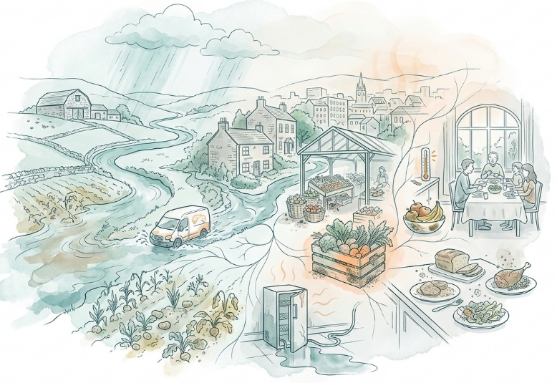
The food system serves the whole West Yorkshire population, so disruption to availability, affordability, storage or distribution could have effects across the region. However, exposure is likely to be greatest in lower-income neighbourhoods and among households with limited transport, restricted dietary choice or existing reliance on food support.
A separate assessment of the spatial indicators of vulnerability in West Yorkshire found that 29.16% of residents work in lower-income occupations and 25.81% of households lack private transport. Bradford has the lowest estimated household income among the five districts, while Wakefield has the highest share of lower-income occupations. These are vulnerability indicators rather than direct measures of food insecurity, but they identify sizeable groups that may have less flexibility to absorb food-price rises or travel further for affordable food. Local-authority averages may conceal sharper neighbourhood differences.
More direct evidence confirms uneven local exposure:
- Bradford Food Insecurity Health Needs Assessment 2026 identifies poverty as the strongest predictor of food insecurity in Bradford. It reports higher food insecurity among the defined underserved communities in its study and identifies eight priority neighbourhoods, while noting gaps in nearby community food provision in some areas.
- Food insecurity – Wakefield JSNA reports that 42% of Wakefield’s population lived in neighbourhoods within the highest-risk national quintile of its Food Insecurity Risk Index in 2023–24. Higher-risk areas included central Wakefield, Castleford, Knottingley, Hemsworth and South Kirkby.
- Priority Places for Food Index reports that 37% of neighbourhoods in Yorkshire and the Humber are priority places for food access. Regional priority areas tend to combine socio-economic barriers, fuel poverty, family food-support needs and poor access to food retail or online delivery.
- Food Standards Agency research finds that extreme temperatures, floods, drought and damage to infrastructure can affect production, distribution, storage and retail, causing supply variability, food-safety pressures and price increases. This is UK evidence but describes pathways relevant to West Yorkshire’s reliance on national and international supply chains.
The score is significant rather than high because current evidence does not quantify what proportion of West Yorkshire is directly exposed to climate-related food-safety incidents, cold-chain failures or loss of nutritional quality.

Sensitivity: How significant could this risk be for the West Yorkshire region?
Significant
Sensitivity

The likely consequences are substantial. Higher temperatures can promote spoilage and pathogen growth. Flooding can contaminate food and water and damage storage, transport and refrigeration. Climate-related production shocks can also reduce dietary diversity or make fresh food less affordable, with greater effects on households already experiencing poverty or poor health.³
Foodborne illness can cause serious harm, particularly among older people, young children, pregnant people and those with existing health conditions. Evidence links warmer conditions with some foodborne pathogens, although mechanisms and effects vary. Sensitivity is increased by existing inequalities. The spatial vulnerability assessment records that 13.71% of West Yorkshire households include someone with long-term ill health and 7.78% of residents report that their daily activities are limited a lot.⁴ These groups may be more affected by poor nutrition, foodborne illness or disruption to care and food delivery. Regional health sector stakeholders consulted during this assessment identified practical concerns including heat creating difficulties storing enteral feeds in a West Yorkshire healthcare setting.

Adaptive Capacity: Existing programmes, plans, policies, budgets and community action
Moderate
Adaptive Capacity

West Yorkshire has active food-support networks, local strategies, public-health partnerships and health-service planning. However, most measures address poverty, sustainability or emergency food access rather than explicitly managing climate-related food contamination, nutritional quality, refrigeration failure or supply-chain disruption.
Existing capacity includes:
- The West Yorkshire Food Poverty Network connects food-aid networks across Bradford and Keighley, Calderdale, Kirklees, Leeds and Wakefield. Its work includes coordination among providers, food redistribution, affordable-food initiatives, holiday provision and links to debt, welfare and health advice.
- Food security and economy, part of the Leeds Food Strategy, includes action on income, access to healthy food, connections between food providers and advice services, and inclusive local food initiatives. These measures can strengthen household resilience, although the strategy does not present them as climate adaptation.
- Wakefield has food banks, pantries and hot-food schemes, together with the Wakefield District Good Food Partnership.⁶ The partnership seeks a safe, affordable, equitable and sustainable local food system.
- The West Yorkshire Integrated Care Board Green Plan includes food, nutrition and catering, supply-chain procurement and adaptation among its focus areas. It also records sustainability training, climate fellowships and a food-waste project within a local NHS trust.
- Yorkshire Ambulance Trust Climate Adaptation Plan recognises that health-service supply chains, including food, need to remain resilient to weather events and includes emergency preparedness, business-continuity and adverse-weather arrangements.
Capacity remains fragmented however and no substantive evidence of coordinated regional adaptation specifically for food safety and nutrition has been found. Adaptive capacity has therefore been scored as moderate.

Annex: Scoring Matrix
The scoring methodology uses the following formula to calculate overall vulnerability for each risk/opportunity area.
Exposure
Sensitivity
Adaptive Capacity
Overall Vulnerability
Exposure, sensitivity and adaptive capacity are scored on a scale of 0-3 (see below).

Exposure
The presence of people, livelihoods, species or ecosystems, environmental functions, services, and resources, infrastructure, or economic, social, or cultural assets in places and settings that could be adversely affected.
Score | Rating | Description | Area or System exposed
3 | High | 50-100% of affected area/system expose to climate hazards | 50-100%
2 | Significant | 25-50% of affected area/system expose to climate hazards | 25-50%
1 | Moderate | 10-25% of affected area/system expose to climate hazards | 10-25%
0 | Low or None | 0-10% of affected area/system expose to climate hazards | 0-10%

Sensitivity
The degree to which a system or species is adversely or beneficially affected by climate variability or climate change.

Score | Rating | Description
3 | High sensitivity | Potential loss of life or high impact caused by climate change. Difficult or impossible for systems to recover
2 | Significant sensitivity | If climate changes event happens, high impact, but not catastrophic
1 | Moderate sensitivity | If climate changes event happens, there is an impact, but not very disruptive
0 | None or low sensitivity | Limited or no consequence from climate event

Adaptive Capacity
The ability of current systems, institutions, structural units, humans and other organisms to adjust to potential damage, to take advantage of opportunities, or to respond to consequences
Score | Rating | Description
0 | Low or No Adaptive Capacity | Limited or no local or national policies or programmes in place to currently address specific risk/opportunity
1 | Moderate Adaptive Capacity | Either some local or national policies and programmes in place, that may indirectly address risk/opportunity or are limited in scope
2 | Significant Adaptive Capacity | Either local or national policies and programmes in place specifically addressing risk, but there are still gaps
3 | High Adaptive Capacity | Well established systems (policies, programmes) that are currently addressing this risk

Vulnerability
The final vulnerability score is calculated by adding the exposure and sensitivity scores, then subtracting the adaptive capacity score. Vulnerability is then categorised from Very High to Very Low depending on the final score.
Score | Rating
Very High | Total Score between 5 & 6
High | Total Score between 3 & 4
Medium | Total Score between 1 & 2
Low | Total Score between -1 & 0
Very Low | Total Score between -3 & -2

The detailed scoring matrix is provided in Annex: Scoring Matrix.
Local Authority Climate Report | West Yorkshire
CCRA4 Technical Report | Risks to Health and Wellbeing (2026)
Spatial Indicators of Vulnerability in the West Yorkshire Combined Authority (2026)
Bradford Joint Strategic Needs Assessment, Food Insecurity Health Needs Assessment (2026)
Wakefield Joint Strategic Needs Assessment, Food Insecurity (2026)
Priority Places for Food Index | Consumer Data Research Centre
Impact of Climate Change on the UK Food System | FSA (2024)
Kovats, R. S. et al. (2004), “The effect of temperature on food poisoning: a time-series analysis of salmonellosis in ten European countries”, Epidemiology & Infection, 132(3), 443–453
West Yorkshire Health Sector Stakeholder Focus Group, 7 September 2026, facilitated for the West Yorkshire Climate Risk Assessment
West Yorkshire Food Poverty Network
Food security and economy | Leeds City Council
West Yorkshire Integrated Care Board Green Plan 2025-2028
Yorkshire Ambulance Service NHS Trust, Climate Adaptation Plan 2024–2029

