I6: Risks to Rail Transport Systems

Summary vulnerability assessment
This report forms part of the West Yorkshire Combined Authority Climate Risk and Vulnerability Assessment and examines risks to rail transport systems from climate change.
Flooding, intense rainfall, ground movement, heat and high winds can damage tracks, stations, signalling and other rail infrastructure. Most assessed freight rail segments have a Low or Very Low forecast impact score. However, the assessment does not cover passenger-only routes, and local sections of the network remain exposed to hazards, including in the Calder Valley.
Weather-related damage and line closures can delay or cancel passenger and freight services. Disruption can affect access to employment, education and essential services, as well as movement of goods. Its effects may spread across the network where capacity is already constrained or alternative routes are limited.
Network Rail’s weather monitoring, maintenance, operational controls and adaptation plans provide a solide basis for managing these risks. Targeted works have also addressed surface-water flooding east of Luddendenfoot. However, the available evidence does not show how much planned investment will reduce disruption in West Yorkshire, and gaps remain in assessing linked infrastructure and local outcomes.
Taken together, these findings give rail transport systems a low overall vulnerability score.
0
Low
2
Significant
2
Significant
0
Low
Exposure
Sensitivity
Adaptive Capacity
Overall Vulnerability

Risk summary
Climate change can damage rail infrastructure and disrupt passenger and freight services. The main hazards are flooding, intense rainfall, ground movement, heat and high winds. Flooding can inundate tracks and stations, wash material from beneath track, damage bridge foundations and trigger landslips. Heat can buckle rails, cause overhead wires to sag and overheat signalling equipment. Wind can damage overhead equipment or bring trees and debris onto the line. The national assessment concludes that the magnitude of this risk will increase as rainfall patterns, temperature and extreme weather change, and that more adaptation action is needed.

Exposure: How exposed is the West Yorkshire region to this risk?
Low or None
Exposure

Using Transport for the North’s Climate Vulnerability Tool data for rail networks in West Yorkshire, most of the freight network in the West Yorkshire network was found to have a low forecast impact score (based on a combination of modelled hazard exposure and relevant transport demand). 5.11% of West Yorkshire’s freight rail network is in the Moderate forecast Impact band, while 83.82% is Low and 11.07% is Very Low. No freight sections are High or Very High. Moderate sections are concentrated mainly in central and south-eastern parts of the network. The Climate Vulnerability Tool provides separate scores for current and forecast conditions.
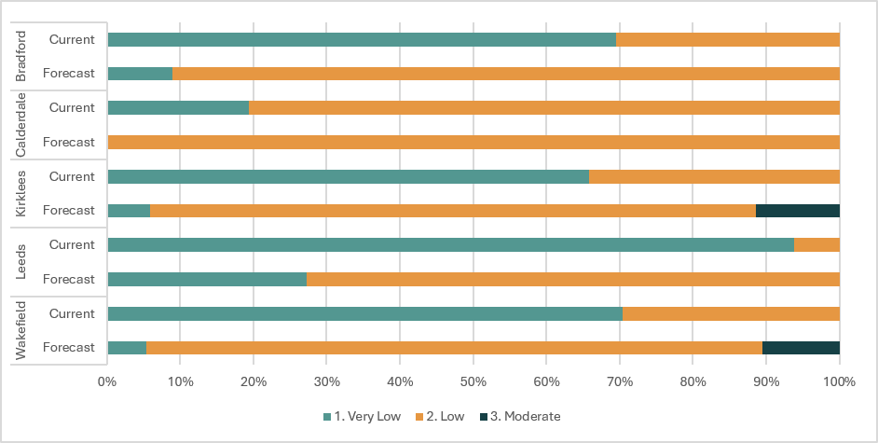
Figure 1: Current and forecast impact score for freight rail across all local authorities
Figure 1 shows a shift from the Very Low to the Low Impact band under the forecast scenario in all five local authority areas. Under current conditions, most freight rail segments fall within the Very Low band, although Calderdale has a larger share in the Low band. Under forecast conditions, almost all segments in Calderdale fall within the Low band, which also becomes the main band in Bradford, Kirklees and Wakefield. Leeds retains the largest share in the Very Low band. Small proportions of the network in Kirklees and Wakefield move into the Moderate band, but no segments fall within the High or Very High bands.
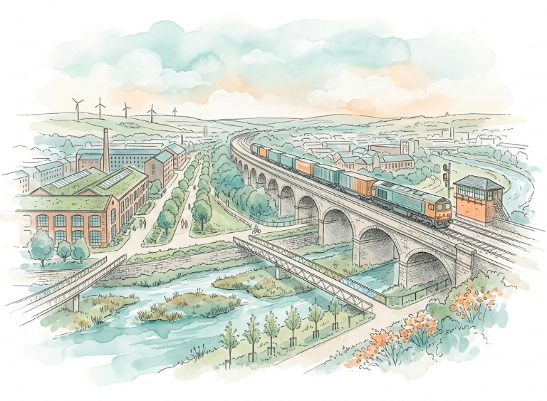
This supports an overall low or none exposure score under the assessment scale because less than 10% of the assessed freight system has elevated relative potential exposure. However, this is a composite measure combining freight demand and modelled hazards, rather than a direct measure of physical exposure. The freight result also does not cover all passenger-only routes.
Calderdale has steep valley sides, rapid runoff and recurrent flooding around settlements including Todmorden, Hebden Bridge, Mytholmroyd, Luddendenfoot, Sowerby Bridge and Brighouse. Railway stations serve all these places except Luddendenfoot, where the line still passes through. These conditions can expose rail corridors sharing narrow valley floors with rivers, roads and other infrastructure. Network Rail has completed measures addressing railway-related surface-water flood risk at three sites east of Luddendenfoot, confirming that locally significant rail exposure exists, although the public record does not identify the sites or quantify the reduction in risk.
This “low ” exposure assessment is well supported by the Transport for the North’s Climate Vulnerability Tool for freight rail, but a complete system-wide expouse percentage cannot be calculated because there is no passenger-rail Impact score and the strategic model omits asset condition, drainage performance, compound hazards and cascading failures.5

Sensitivity: How significant could this risk be for the West Yorkshire region?
Significant
Sensitivity

Weather-related failures can cause delays, cancellations, temporary line closures and safety restrictions. Disruption can affect access to employment, education and essential services, interrupt freight movements and shift passengers onto already constrained roads and buses. Rail also depends on electricity, telecommunications, drainage, vegetation management and access routes for maintenance and emergency response.3,
West Yorkshire’s rail network is economically and socially important. The regional Rail Strategy describes rail as central to the public transport system, connecting the main towns and cities and carrying passenger and freight movements across the Pennines and along the Aire Valley. It also identifies ageing infrastructure, capacity constraints and long-term investment needs. These existing pressures reduce the system’s ability to absorb additional disruption.
Stakeholder evidence identifies capacity challenges at Leeds station and notes that a network operating close to capacity has less ability to absorb knock-on disruption. It also indicates that solutions to these constraints are generally long term and expensive. Current research has not yet quantified how the closure of particular West Yorkshire lines would cascade through the network, so the regional consequences of individual failures remain uncertain.
A Significant score is more appropriate than High because the evidence supports major disruption and economic effects, but does not show that a climate event would make the West Yorkshire rail system impossible to recover or necessarily cause widespread loss of life. Nationally, the safety-first approach, monitoring, and operational restrictions help protect passengers and staff, although serious weather-related accidents remain possible.3,8

Adaptive Capacity: Existing programmes, plans, policies, budgets and community action
Significant
Adaptive Capacity
The rail sector has established risk-management, regulatory and investment arrangements. Network Rail uses regional Weather Resilience and Climate Change Adaptation plans, weather monitoring, emergency arrangements, drainage and earthworks management, remote monitoring and operational measures such as speed restrictions. Its 2024 to 2029 plans identify around £2.8 billion of expenditure on activities with primary weather-resilience benefits, including drainage, earthworks, electrification, signalling, structures and track. This is national and regional funding, not a West Yorkshire allocation.
Network Rail’s fourth adaptation report describes an integrated climate risk assessment, regional adaptation plans, adaptation-pathway development and work to embed climate change into policies, standards and asset modelling. It also acknowledges that considerable work remains, including better metrics, training, interdependency assessment and identification of asset thresholds. The Office of Rail and Road provides safety and economic oversight, monitors regional plan delivery and secured additional core-renewal commitments during the 2024 to 2029 funding review.8
West Yorkshire also benefits from current infrastructure programmes. Work between Huddersfield and Leeds has included track renewal, drainage and tunnel works, overhead-line foundations and station preparations. These works may improve reliability and asset condition, but the published update does not state climate design thresholds or demonstrate improved performance during extreme weather. In Calderdale, completed surface-water measures east of Luddendenfoot provide a local example of targeted rail adaptation.
Important gaps remain. The regional rail strategy is principally an investment and service strategy rather than a rail climate-adaptation plan.9 Independent reviews have found strengths in Network Rail’s overall framework, but gaps in long-term scenarios, interdependencies, links between adaptation and asset management, performance metrics and building-specific assessments.8 Available evidence also does not identify a dedicated West Yorkshire rail-adaptation budget or demonstrate how much planned investment will reduce disruption locally.

Annex: Scoring Matrix
The scoring methodology uses the following formula to calculate overall vulnerability for each risk/opportunity area.
Exposure
Sensitivity
Adaptive Capacity
Overall Vulnerability
Exposure, sensitivity and adaptive capacity are scored on a scale of 0-3 (see below).

Exposure
The presence of people, livelihoods, species or ecosystems, environmental functions, services, and resources, infrastructure, or economic, social, or cultural assets in places and settings that could be adversely affected.
Score | Rating | Description | Area or System exposed
3 | High | 50-100% of affected area/system expose to climate hazards | 50-100%
2 | Significant | 25-50% of affected area/system expose to climate hazards | 25-50%
1 | Moderate | 10-25% of affected area/system expose to climate hazards | 10-25%
0 | Low or None | 0-10% of affected area/system expose to climate hazards | 0-10%

Sensitivity
The degree to which a system or species is adversely or beneficially affected by climate variability or climate change.

Score | Rating | Description
3 | High sensitivity | Potential loss of life or high impact caused by climate change. Difficult or impossible for systems to recover
2 | Significant sensitivity | If climate changes event happens, high impact, but not catastrophic
1 | Moderate sensitivity | If climate changes event happens, there is an impact, but not very disruptive
0 | None or low sensitivity | Limited or no consequence from climate event

Adaptive Capacity
The ability of current systems, institutions, structural units, humans and other organisms to adjust to potential damage, to take advantage of opportunities, or to respond to consequences
Score | Rating | Description
0 | Low or No Adaptive Capacity | Limited or no local or national policies or programmes in place to currently address specific risk/opportunity
1 | Moderate Adaptive Capacity | Either some local or national policies and programmes in place, that may indirectly address risk/opportunity or are limited in scope
2 | Significant Adaptive Capacity | Either local or national policies and programmes in place specifically addressing risk, but there are still gaps
3 | High Adaptive Capacity | Well established systems (policies, programmes) that are currently addressing this risk

Vulnerability
The final vulnerability score is calculated by adding the exposure and sensitivity scores, then subtracting the adaptive capacity score. Vulnerability is then categorised from Very High to Very Low depending on the final score.
Score | Rating
Very High | Total Score between 5 & 6
High | Total Score between 3 & 4
Medium | Total Score between 1 & 2
Low | Total Score between -1 & 0
Very Low | Total Score between -3 & -2

The detailed scoring matrix is provided in Annex: Scoring Matrix.
Local Authority Climate Report | West Yorkshire
Chapter 6: Infrastructure - UK Climate Risk
Transport for the North Climate Vulnerability Tool
Road and Rail Assessment for West Yorkshire Climate Risk Assessment 2026
Calderdale Adopted Flood Risk and Drainage SPD - Details - Keystone
Resilient Infrastructure Actions - Eye on Calderdale
Climate change adaptation at the Office of Rail and Road, 2024
West Yorkshire Combined Authority Rail Strategy 2024
Key stakeholder interview, 6 August 2026, facilitated for the West Yorkshire Climate Risk Assessment
Network Rail, Weather Resilience and Climate Change Adaptation, Summary of Regional plans for 2024-2029
Network Rail Fourth Adaption Report – December 2024
Another step closer to faster, greener services across the Pennines - Transpennine Route Upgrade
Resilient Infrastructure Actions - Eye on Calderdale

