I7: Risks to aviation and maritime transport systems for West Yorkshire

Summary vulnerability assessment
This report forms part of the West Yorkshire Combined Authority Climate Risk and Vulnerability Assessment and examines risks to aviation and maritime transport systems from climate change.
West Yorkshire’s direct exposure is concentrated at Leeds Bradford Airport and on inland waterways, including the Calder and Hebble Navigation and the Aire and Calder Navigation. The region has no seaport, although its businesses depend on ports elsewhere in the UK. Flooding, extreme heat, storms and high winds can disrupt airport operations, while flooding, erosion and drought can damage waterways or restrict navigation.
The region’s exposure score is Low because the airport and waterway assets occupy a limited part of its transport system. Sensitivity is Significant: disruption at these locations could delay travel and freight, affect access to goods and require costly repairs. Storm Ciara’s damage to the Calder and Hebble Navigation shows how a local failure can take years to repair.
National transport adaptation policy, flood-risk management and emergency-planning arrangements provide Significant adaptive capacity. However, published evidence does not show how well these measures protect the airport, waterways or port-dependent supply chains. Gaps also remain in assessing linked infrastructure and the effects of disruption on West Yorkshire.
Taken together, these findings give aviation and maritime transport systems a Low overall vulnerability score.
0
Low
2
Significant
2
Significant
0
Low
Exposure
Sensitivity
Adaptive Capacity
Overall Vulnerability

Risk summary
West Yorkshire’s main direct exposure is through Leeds Bradford Airport and its inland waterways, particularly the Calder and Hebble Navigation and the Aire and Calder Navigation. The region has no seaport, but its businesses and communities depend on maritime freight and supply chains through ports elsewhere in the UK. Climate hazards include river and surface-water flooding, extreme heat, storms and high winds at the airport, and flooding, erosion and drought on navigable waterways. These can damage infrastructure, disrupt flights and navigation, affect workers and passengers, and interrupt freight and supply chains. The national assessment rates the risk as high in magnitude but identifies low confidence in longer-term outcomes and limited evidence on infrastructure interdependencies.

Exposure: How exposed is the West Yorkshire region to this risk?
Low or None
Exposure
Direct exposure is concentrated rather than region-wide. Leeds Bradford Airport is the region’s principal aviation asset, providing domestic and international connections. The Calder and Hebble Navigation crosses Calderdale, Kirklees and Wakefield, while the Aire and Calder Navigation connects Wakefield and Leeds with the Humber system. The Mayor’s Local Transport Plan also identifies air links, waterways, rail freight connections to seaports and major logistics centres as parts of West Yorkshire’s wider transport system.
Flood exposure is established locally, although available evidence did not provide a comprehensive climate-risk assessment for the airport. Calderdale’s waterways are closely connected to the River Calder and can be inundated when river levels rise. The borough’s flood-risk document identifies regular river and surface-water flooding along the Calder Valley, including at Todmorden, Hebden Bridge, Mytholmroyd, Sowerby Bridge, Elland and Brighouse. Leeds also has exposure from rivers, surface water, sewers, groundwater, canals and reservoirs, while Wakefield’s river and canal network includes the Calder, Aire and more than 20km of canal.
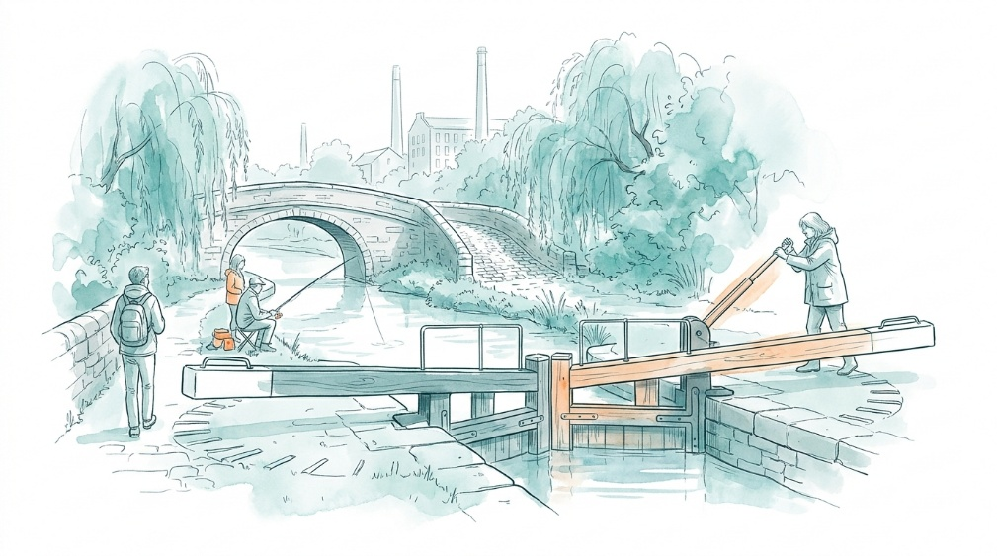
West Yorkshire has no coastal or port infrastructure within its boundary. Maritime exposure is therefore indirect, through dependence on ports, international shipping and connecting road and rail freight routes. Current evidence does not quantify how much of West Yorkshire’s trade or supply chain is dependent on individual ports7, so the exposure score is based on the limited spatial extent of the airport and inland-waterway assets rather than a measured percentage of the regional transport system.
The Combined Authority’s draft freight evidence base confirms that freight is economically important to West Yorkshire and examines international trade, road and rail freight, water freight and port activity. However, the published material does not yet provide a climate-risk assessment of the region’s port-related supply chains.
A tangible example of this indirect exposure is Wakefield Europort, where a commercial operator provides rail services to major deep-sea ports alongside container storage and onward road haulage. This illustrates a connection between West Yorkshire logistics and maritime gateways, but does not establish the region’s overall dependence on any individual port.

Sensitivity: How significant could this risk be for the West Yorkshire region?

Flooding, strong winds and extreme heat could disrupt airport operations, damage runways, terminals, drainage, communications and supporting utilities, cause delays and cancellations, and affect staff and passenger safety.5 National evidence also shows that higher temperatures can reduce aircraft lift and maximum take-off weight, while changes in wind and clear-air turbulence can affect flight operations and increase delays, diversions and fuel use.,
Storm Ciara in February 2020 demonstrates the sensitivity of the Calder and Hebble Navigation. Canal & River Trust reports that floodwater overtopped Figure of Three Locks, causing about £3 million of damage, while a 30-metre section of the Woodside Lock landing and towpath near Elland was washed away. Restoration of Figure of Three Locks and the washed-out towpath was completed in April 2022, with a further £507,000 repair programme subsequently begun at Woodside Lock. This provides a local illustration of the potentially lengthy and costly failure of individual waterway structures.
Canal & River Trust reports that drought can reduce reservoir, river and feeder levels and lead to temporary lock restrictions or closures. No data is available on the frequency, duration or economic effect of drought restrictions on West Yorkshire’s waterways.
Indirect consequences could extend beyond West Yorkshire. The Mayor’s Local Transport Plan identifies Leeds Bradford Airport, the motorway network, rail freight routes and logistics centres as important connections to national and international markets.5 Disruption at the airport, on inland waterways or at external ports could affect passenger travel, freight, manufacturing and access to goods.7

Adaptive Capacity: Existing programmes, plans, policies, budgets and community action
Significant
Adaptive Capacity
Adaptive capacity is supported mainly by national transport adaptation policy and established local flood-risk and emergency-planning arrangements.
National arrangements include the Department for Transport’s Climate Adaptation Strategy for Transport, climate-risk assessment guidance for ports and airports14, Civil Aviation Authority risk assessment and action planning, and fourth-round Adaptation Reporting Power reports from aviation and port operators. The national strategy includes work on aviation awareness and planning, maritime disruption monitoring, interdependencies, resilience standards and sector collaboration.18
Local capacity is strongest in flood-risk management and emergency preparedness. Calderdale, Leeds, Kirklees and Wakefield have Local Flood Risk Management Strategies, Lead Local Flood Authority responsibilities, planning controls, flood mapping and measures covering sustainable drainage, natural flood management, infrastructure maintenance and emergency response. 8,9,10, The West Yorkshire Resilience Forum Annual Report 2023/24 describes a multi-agency Severe Weather Plan, training and exercises, risk assessment work and arrangements for coordinated emergency response.
Leeds Bradford Airport’s Sustainability Strategy refers to long-term resilience but does not publish an asset-level assessment of physical climate risks to the airport site. In March 2026, the airport joined the Aire Resilience Company, which funds natural flood management across the wider River Aire catchment. This demonstrates support for regional catchment resilience, but the published announcement does not show how the airport’s runways, terminal, drainage, utilities or access routes are being adapted.
Nationally, the CCRA4 assessment finds little evidence on the effectiveness of implemented adaptation for aviation, ports and inland waterways, and limited action addressing interdependencies with electricity, water, telecommunications, roads and rail.5 Public information on dedicated adaptation budgets, airport-specific hazard exposure, local waterway drought risk and the resilience of West Yorkshire’s port-dependent supply chains is also limited.7

Annex: Scoring Matrix
The scoring methodology uses the following formula to calculate overall vulnerability for each risk/opportunity area.
Exposure
Sensitivity
Adaptive Capacity
Overall Vulnerability
Exposure, sensitivity and adaptive capacity are scored on a scale of 0-3 (see below).

Exposure
The presence of people, livelihoods, species or ecosystems, environmental functions, services, and resources, infrastructure, or economic, social, or cultural assets in places and settings that could be adversely affected.
Score | Rating | Description | Area or System exposed
3 | High | 50-100% of affected area/system expose to climate hazards | 50-100%
2 | Significant | 25-50% of affected area/system expose to climate hazards | 25-50%
1 | Moderate | 10-25% of affected area/system expose to climate hazards | 10-25%
0 | Low or None | 0-10% of affected area/system expose to climate hazards | 0-10%

Sensitivity
The degree to which a system or species is adversely or beneficially affected by climate variability or climate change.

Score | Rating | Description
3 | High sensitivity | Potential loss of life or high impact caused by climate change. Difficult or impossible for systems to recover
2 | Significant sensitivity | If climate changes event happens, high impact, but not catastrophic
1 | Moderate sensitivity | If climate changes event happens, there is an impact, but not very disruptive
0 | None or low sensitivity | Limited or no consequence from climate event

Adaptive Capacity
The ability of current systems, institutions, structural units, humans and other organisms to adjust to potential damage, to take advantage of opportunities, or to respond to consequences
Score | Rating | Description
0 | Low or No Adaptive Capacity | Limited or no local or national policies or programmes in place to currently address specific risk/opportunity
1 | Moderate Adaptive Capacity | Either some local or national policies and programmes in place, that may indirectly address risk/opportunity or are limited in scope
2 | Significant Adaptive Capacity | Either local or national policies and programmes in place specifically addressing risk, but there are still gaps
3 | High Adaptive Capacity | Well established systems (policies, programmes) that are currently addressing this risk

Vulnerability
The final vulnerability score is calculated by adding the exposure and sensitivity scores, then subtracting the adaptive capacity score. Vulnerability is then categorised from Very High to Very Low depending on the final score.
Score | Rating
Very High | Total Score between 5 & 6
High | Total Score between 3 & 4
Medium | Total Score between 1 & 2
Low | Total Score between -1 & 0
Very Low | Total Score between -3 & -2

The detailed scoring matrix is provided in Annex: Scoring Matrix.
For this report, ‘Navigation’ means a navigable waterway made up of engineered river sections and canal cuts, with structures such as locks and weirs.
Local Authority Climate Report | West Yorkshire
Climate Change Committee, A Well Adapted UK, 2026
Chapter 6: Infrastructure - UK Climate Risk
Calder & Hebble Navigation | Canal maps
West Yorkshire Combined Authority Local Transport Plan
Calderdale Flood Risk & Drainage SPD, 2024
Leeds Local Flood Risk Management Strategy, n.d.
Wakefield Local Flood Risk Management Strategy, 2014
Chapter 6: Infrastructure - UK Climate Risk
The West Yorkshire Transport Evidence Base -Freight
Yorkshire and the Humber | Maritime Transport
UK Civil Aviation Authority ARP4 Climate Adaptation Report 2024
ICAA Environmental Protection - Climate Adaptation Synthesis Report
Repairs underway for storm-damaged Woodside Mills Lock landing and towpath in Elland | Canal & River Trust
Notices and stoppages | Canal & River Trust
Climate Risk Assessment Guidance for the Transport Sector- Non-technical Summary
Climate adaption reporting fourth round: aviation - GOV.UK
Kirklees local flood risk management full strategy, n.d.
West Yorkshire Resilience Forum Annual Report 2023-24
Leeds Bradford Airport Sustainability Strategy
Leeds Bradford Airport Joins Aire Resilience Company

