I8: Risks to Digital and Communications Systems

Summary vulnerability assessment
This report forms part of the West Yorkshire Combined Authority Climate Risk and Vulnerability Assessment and examines risks to digital and communications systems from climate change.
Digital networks and the services that rely on them extend across West Yorkshire. Flooding can affect exchanges, cabinets and underground infrastructure; heat can disrupt equipment and cooling; and storms and high winds can damage masts, poles and overhead cables. Power cuts can cause wider communications failures. The exposure score is Significant, although the extent of infrastructure exposed to each hazard remains uncertain because local asset-level mapping is not available.
Sensitivity is High. Disruption could affect emergency calls and warnings, health and care services, transport information, digital payments and access to public services. The consequences may be greatest during prolonged power outages or when several systems fail together. People with fewer ways to access digital services may face additional barriers. The high score reflects the potential effects on essential services, not an expectation that every outage would be severe.
National regulation, industry guidance and established engineering practices provide Significant adaptive capacity, supported by regional emergency planning and service-level business continuity. However, public evidence does not show how well local assets are protected, how long backup power would last, or whether alternative connections would maintain essential services during a widespread disruption.
Taken together, Significant exposure, High sensitivity and Significant adaptive capacity give digital and communications systems a High overall vulnerability score.
2
Significant
3
High
2
Significant
3
High
Exposure
Sensitivity
Adaptive Capacity
Overall Vulnerability

Risk summary
Climate hazards can damage or disrupt data centres, telephone masts, exchanges, poles, cables and broadband networks. Flooding can inundate sites and underground infrastructure. Heat can increase cooling demand and equipment failure. Storms, high winds and falling trees can damage overhead networks. Drought can constrain water-dependent cooling. Disruption is often local, but dependence on electricity means a power cut can cause wider communications failure. The Climate Change Committee assesses the present UK risk as medium, potentially rising to high later this century, but reports low confidence because available assessments are often qualitative and evidence on future impacts is limited.

Exposure: How exposed is the West Yorkshire region to this risk?
Significant
Exposure
Digital infrastructure and the services that depend on it extend across all five West Yorkshire districts. The regional Digital Blueprint reports high but uneven connectivity, including widespread availability of gigabit-capable broadband and 4G, but more variable availability of full fibre to the premises. Some places have fewer connectivity options if a service fails.
Recent Project Gigabit delivery shows that hard-to-reach connectivity gaps remain in parts of the wider region, including rural communities around Huddersfield and Bradford. This illustrates uneven access to modern networks but does not measure climate exposure or network redundancy across West Yorkshire.
Exposure varies by hazard and asset. Low-lying exchanges, cabinets, ducts and data facilities may be exposed to river or surface-water flooding. Masts, poles and overhead cables are exposed to high winds, lightning and falling trees. Data centres and other equipment facilities can be exposed to overheating, water stress and interruption of power or cooling. Tech-UK’s 2016 UK adaptation report records communications failures affecting a telephone exchange and a dedicated data centre during flooding in York and Leeds in 2015, providing a relevant local and nearby example. However, no available evidence maps West Yorkshire’s telecoms assets against present or future flood, heat or wind hazards. The extent of physical infrastructure exposed therefore remains uncertain.

Sensitivity: How significant could this risk be for the West Yorkshire region?
High
Sensitivity
Loss of communications can affect emergency calls, severe-weather warnings, health and care systems, transport information, digital payments, remote working and access to public services. Power loss is a key source of vulnerability. Ofcom’s national modelling indicates that mobile emergency-call availability falls as an outage continues because relatively few mast sites have long-duration backup. This national evidence does not establish West Yorkshire’s backup capacity, but it shows how an extended regional power failure could create risks to life and essential services.
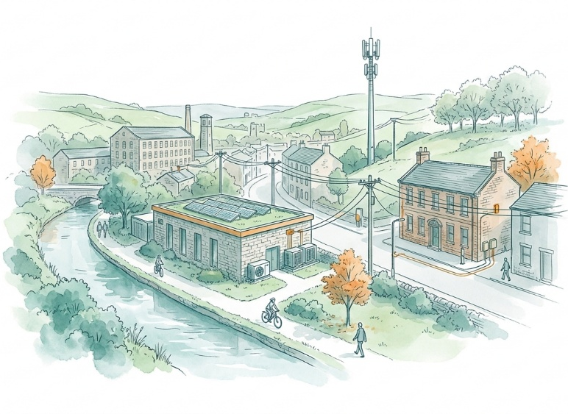
West Yorkshire’s growing use of digital systems increases the potential consequences of disruption. The Digital Blueprint describes reliance on digital connectivity across businesses, connected places, transport, health technologies and day-to-day services.4 The West Yorkshire Health and Care Partnership also identifies shared care records, networked services, legacy technology and business continuity for prolonged system outages as regional priorities. Sensitivity is also shaped by digital exclusion. People without affordable access, suitable devices, skills or alternative ways to obtain information may be particularly affected when communications fail. NHS England’s Digital Exclusion Risk Atlas combines indicators covering connectivity, affordability, devices, skills and wider demographic factors at neighbourhood level. This could be used to identify West Yorkshire communities where loss of digital access may compound existing barriers to health and care services.
Impacts are likely to be most severe where several systems fail together. Regional evidence notes that power outages can bring down telecommunications and hinder potentially life-saving communications. National evidence similarly identifies cascading disruption between electricity, communications and public services as a priority risk. The high score reflects the plausible threat to emergency and essential services, rather than evidence that every individual outage would have severe consequences.

Adaptive Capacity: Existing programmes, plans, policies, budgets and community action
Significant
Adaptive Capacity
National telecommunications guidance provides established principles for network resilience, including redundancy, separation, monitoring, protection, recovery planning and business continuity. Ofcom has also published resilience guidance and convenes government, regulators and industry on climate adaptation. Ofcom updated its Network and Service Resilience Guidance in June 2026, including clearer expectations for backup power in mobile radio-access networks. Ofcom also reports stronger coordination between telecoms and electricity-sector bodies during major incidents. This strengthens national adaptive capacity, although the guidance does not establish the duration or geographic coverage of backup power in West Yorkshire.
Sector reporting describes measures addressing flooding, storms, temperature and loss of key inputs. Data centres commonly use resilient site selection, duplicated power, cooling and connectivity, although small on-premises facilities may have weaker provision.
Regional capacity includes the Combined Authority’s Digital Blueprint and action planning to 20304 and health-sector work on cyber resilience, mutual aid and prolonged system outages.9 These measures strengthen general resilience, even where they do not explicitly address physical climate risks to telecoms assets. In addition, West Yorkshire Prepared provides public guidance on maintaining access to information during power cuts, including battery-powered radios, charged devices, power banks and Priority Services registration. This improves household preparedness, but it should be treated as a measure for coping with disruption rather than evidence that communications networks themselves are climate-resilient.
National regulation, industry guidance and established engineering practices specifically address network resilience and service continuity. West Yorkshire also has multi-agency emergency arrangements and service-level business-continuity activity. However, little public evidence was found on local telecoms asset protection, backup-power duration, network diversity, investment or tested recovery standards. Ofcom records industry barriers including limited climate data, coordination difficulties and dependence on energy.14 The Climate Change Committee’s proposed outcome is continuity for emergency services and critical infrastructure, but the supplied evidence does not show that this is yet assured locally.

Annex: Scoring Matrix
The scoring methodology uses the following formula to calculate overall vulnerability for each risk/opportunity area.
Exposure
Sensitivity
Adaptive Capacity
Overall Vulnerability
Exposure, sensitivity and adaptive capacity are scored on a scale of 0-3 (see below).

Exposure
The presence of people, livelihoods, species or ecosystems, environmental functions, services, and resources, infrastructure, or economic, social, or cultural assets in places and settings that could be adversely affected.
Score | Rating | Description | Area or System exposed
3 | High | 50-100% of affected area/system expose to climate hazards | 50-100%
2 | Significant | 25-50% of affected area/system expose to climate hazards | 25-50%
1 | Moderate | 10-25% of affected area/system expose to climate hazards | 10-25%
0 | Low or None | 0-10% of affected area/system expose to climate hazards | 0-10%

Sensitivity
The degree to which a system or species is adversely or beneficially affected by climate variability or climate change.

Score | Rating | Description
3 | High sensitivity | Potential loss of life or high impact caused by climate change. Difficult or impossible for systems to recover
2 | Significant sensitivity | If climate changes event happens, high impact, but not catastrophic
1 | Moderate sensitivity | If climate changes event happens, there is an impact, but not very disruptive
0 | None or low sensitivity | Limited or no consequence from climate event

Adaptive Capacity
The ability of current systems, institutions, structural units, humans and other organisms to adjust to potential damage, to take advantage of opportunities, or to respond to consequences
Score | Rating | Description
0 | Low or No Adaptive Capacity | Limited or no local or national policies or programmes in place to currently address specific risk/opportunity
1 | Moderate Adaptive Capacity | Either some local or national policies and programmes in place, that may indirectly address risk/opportunity or are limited in scope
2 | Significant Adaptive Capacity | Either local or national policies and programmes in place specifically addressing risk, but there are still gaps
3 | High Adaptive Capacity | Well established systems (policies, programmes) that are currently addressing this risk

Vulnerability
The final vulnerability score is calculated by adding the exposure and sensitivity scores, then subtracting the adaptive capacity score. Vulnerability is then categorised from Very High to Very Low depending on the final score.
Score | Rating
Very High | Total Score between 5 & 6
High | Total Score between 3 & 4
Medium | Total Score between 1 & 2
Low | Total Score between -1 & 0
Very Low | Total Score between -3 & -2

The detailed scoring matrix is provided in Annex: Scoring Matrix.
Local Authority Climate Report | West Yorkshire
Chapter 6: Infrastructure - UK Climate Risk
West Yorkshire Combined Authority: Digital Blueprint Presentation
West Yorkshire Digital Blueprint Evidence Base
Fast, reliable broadband through Project Gigabit | Quickline
Tech UK Climate change adaptation report
Ofcom Mobile RAN power resilience: Technical report and CFI update
Using digital and innovation to support delivery: West Yorkshire Health & Care Partnership
NHS England » The Digital Exclusion Risk Atlas (DERA)
Yorkshire and Humber Climate Commission Insight-Paper-Infrastructure.pdf
A Well-Adapted UK - Climate Change Committee
EC-RRG Resilience Guidelines for Providers of Critical National Telecommunications Infrastructure
Ofcom Resilience to climate change in the telecoms sector 2024
Ofcom Network and Service Resilience Guidance for Communications Providers 2026
Future-Proofing Digital Infrastructure: Climate Resilience in the Data Centre Sector
West Yorkshire Prepared power cuts
Well-adapted digital and telecoms system - Climate Change Committee

