N10: Risks to Food Security

Summary vulnerability assessment
This report forms part of the West Yorkshire Combined Authority Climate Risk and Vulnerability Assessment and examines risks to food security in the region. West Yorkshire depends on climate-sensitive national and international food supply chains, while substantial areas of agricultural land face heat, drought, flooding, storms, pests and disease. The assessment rates exposure and sensitivity as significant because disruption could reduce food availability, increase prices and worsen existing food insecurity, particularly among low-income households and other groups with limited financial or practical capacity to respond. Food partnerships, food-aid networks, local strategies and community programmes provide significant adaptive capacity, but most address poverty, health or sustainability rather than climate disruption directly. Gaps remain in regional planning, long-term funding, supply-chain testing, emergency capacity and arrangements for prolonged disruption.
The resulting overall vulnerability rating is medium. The figure below summarises the assessment scores for exposure, sensitivity, adaptive capacity and overall vulnerability.
2
Significant
2
Significant
2
Significant
2
Medium
Exposure
Sensitivity
Adaptive Capacity
Overall Vulnerability

Risk summary
Climate change can affect food security through damage to crops, livestock, fisheries and ecosystems in the United Kingdom and overseas. Heat, drought, flooding, storms, pests and disease can disrupt production, processing, storage and transport. These disruptions can reduce availability and increase prices. The effects are likely to combine with poverty, high household costs and other supply-chain shocks, placing greatest pressure on people who already struggle to afford a healthy diet. The national assessment rates the risk as High now and Very high in future periods, with critical action needed.

Exposure: How exposed is the West Yorkshire region to this risk?
Significant
Exposure
Exposure extends across West Yorkshire because residents, food businesses, public services and community organisations all depend on national and international food supply chains. The United Kingdom sources food through domestic production and trade at an overall ratio of about 60:40. It remains particularly dependent on imports for fruit, vegetables and seafood, including supplies from countries facing climate and sustainability pressures.
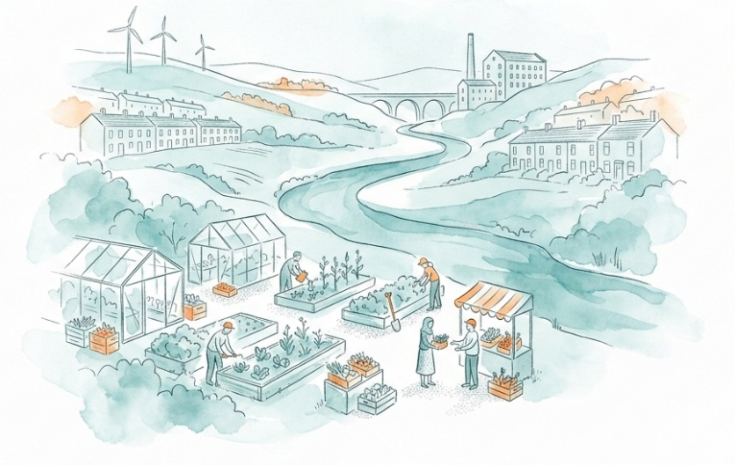
Heat also creates risks beyond primary production. Perishable foods depend on temperature-controlled storage and transport, and national CCRA4 supporting research identifies rising ambient temperatures and more frequent or prolonged heatwaves as risks to cold-chain resilience. The evidence available to this assessment did not identify the location, capacity or climate preparedness of cold-storage and distribution assets within West Yorkshire, so the scale of local exposure cannot yet be quantified.
West Yorkshire also has substantial agricultural exposure. Agricultural land in Grades 1 to 5 covers 126,301 hectares, or 62% of the Combined Authority area. However, the best and most versatile Grades 1, 2 and 3a cover 34,500 hectares, or about 17%.
Exposure to household food insecurity is uneven, as illustrated by recently published Joint Strategic Needs Assessments. In Wakefield, 42% of residents lived in neighbourhoods within the highest-risk national quintile in 2023–24. Higher-risk areas include central Wakefield, Castleford, Knottingley, Hemsworth and South Kirkby. Whilst in Bradford, the health needs assessment identified eight priority neighbourhoods and found gaps in nearby community food provision in Bierley and Tong, Holme Wood and Ravenscliffe.
The Priority Places for Food Index identifies 37% of neighbourhoods in Yorkshire and the Humber as priority places, with concentrations in western and southern Yorkshire. The index measures existing barriers such as income, car access, family food-support needs, fuel poverty and access to food retailers. It does not measure climate exposure directly, but it helps identify places where climate-related price or supply shocks could have greater effects.
The significant score for exposure is therefore made as a precautionary judgement based on region-wide dependence on climate-sensitive national and international supply chains and the substantial extent of agricultural land.

Sensitivity: How significant could this risk be for the West Yorkshire region?
Significant
Sensitivity

Across the region climate-related disruption could increase food prices, restrict access to some foods and reduce dietary quality. Consequences could be particularly serious for low-income households, families with children and people with existing health or access needs, but available local evidence does not demonstrate that a region-wide food-system failure is likely.
National evidence shows that food-secure households declined from 92% in the financial year ending 2020 to 90% in 2023. Yorkshire and the Humber had 88% food-secure households in 2023.⁴ Low-income households, households with children and households including disabled adults had lower levels of food security. Climate change could intensify these existing pressures because extreme weather affects domestic and overseas production and can pass through supply chains as higher prices. The Fourth Climate Change Risk Assessment notes that these costs would be hardest for households that already spend a large share of their income on food.3
Local evidence illustrates the present sensitivity. Calderdale reported more than 12,000 food parcels, over 23,000 community meals and nearly 5,000 affordable-food shops between January and September 2025, although the reporting did not cover all provision. Leeds City Council also states that reliance on food banks and pantries has risen in recent years and that the long-term response must address poverty and financial security as well as emergency provision. These figures and statements mainly reflect poverty and the cost of living. They demonstrate limited household financial buffers, not impacts caused solely by climate change.
Community stakeholders from Wakefield engaged in this analysis identified food poverty and limited access to fresh food as an important indirect climate risk. They also noted that some households lack the money or space to hold emergency supplies, and that community food organisations may need to expand during shortages. These observations are informed local testimony, but they were not quantified or verified across the region.

Adaptive Capacity: Existing programmes, plans, policies, budgets and community action
Significant
Adaptive Capacity
West Yorkshire has established food partnerships, food-aid networks, local authority strategies, redistribution infrastructure, public-health programmes and community growing activity. These provide a substantial foundation for responding to food insecurity. However, much of this capacity addresses poverty, health, sustainability or emergency food aid rather than climate-related disruption explicitly. Coverage, long-term funding and surge capacity remain uncertain.
The West Yorkshire Food Poverty Network brings together district networks from Bradford and Keighley, Calderdale, Kirklees, Leeds and Wakefield. Its work includes coordination between food providers, advice and welfare support, signposting, holiday provision and redistribution through organisations including FareShare Yorkshire.
District strategies add capacity:
- Calderdale’s 2026–34 food strategy is led by Calderdale Food Network and links affordable food, community action, local supply chains, food waste and climate resilience. In 2026 the network received an annual Public Health Grant contribution of £23,300.
- Leeds has a food strategy, an established Food Aid Network and partnerships with FareShare Yorkshire, Rethink Food and FoodWise Leeds. Planned actions include improving access to healthy food, linking food providers to wider advice services and supporting local food businesses and markets.¹¹
- Wakefield has a Good Food Partnership and a network of food banks, pantries and hot-food schemes. Its Joint Strategic Needs Assessment also recognises that climate change could disrupt production and distribution, raise prices and affect vulnerable groups disproportionately.⁷
- Bradford’s climate plan identifies its Good Food Strategy, Sustainable Food Partnership, allotment expansion and community growing initiatives, including food-growing kits and micro-orchards.
Important gaps remain. Current evidence does not identify a West Yorkshire-wide climate food-security plan, quantified emergency food capacity, dedicated regional budget, formal supply-chain stress test or agreed arrangements for prolonged disruption. West Yorkshire does have various emergency and community-response arrangements (for example West Yorkshire Prepared supports communities to plan for incidents including flooding, severe weather and power outages, with food and drink included among the practical needs to consider). However, available evidence does not identify dedicated food-security plans, emergency stock levels, distribution arrangements or tested surge capacity for a prolonged regional disruption.

Annex: Scoring Matrix
The scoring methodology uses the following formula to calculate overall vulnerability for each risk/opportunity area.
Exposure
Sensitivity
Adaptive Capacity
Overall Vulnerability
Exposure, sensitivity and adaptive capacity are scored on a scale of 0-3 (see below).

Exposure
The presence of people, livelihoods, species or ecosystems, environmental functions, services, and resources, infrastructure, or economic, social, or cultural assets in places and settings that could be adversely affected.
Score | Rating | Description | Area or System exposed
3 | High | 50-100% of affected area/system expose to climate hazards | 50-100%
2 | Significant | 25-50% of affected area/system expose to climate hazards | 25-50%
1 | Moderate | 10-25% of affected area/system expose to climate hazards | 10-25%
0 | Low or None | 0-10% of affected area/system expose to climate hazards | 0-10%

Sensitivity
The degree to which a system or species is adversely or beneficially affected by climate variability or climate change.

Score | Rating | Description
3 | High sensitivity | Potential loss of life or high impact caused by climate change. Difficult or impossible for systems to recover
2 | Significant sensitivity | If climate changes event happens, high impact, but not catastrophic
1 | Moderate sensitivity | If climate changes event happens, there is an impact, but not very disruptive
0 | None or low sensitivity | Limited or no consequence from climate event

Adaptive Capacity
The ability of current systems, institutions, structural units, humans and other organisms to adjust to potential damage, to take advantage of opportunities, or to respond to consequences
Score | Rating | Description
0 | Low or No Adaptive Capacity | Limited or no local or national policies or programmes in place to currently address specific risk/opportunity
1 | Moderate Adaptive Capacity | Either some local or national policies and programmes in place, that may indirectly address risk/opportunity or are limited in scope
2 | Significant Adaptive Capacity | Either local or national policies and programmes in place specifically addressing risk, but there are still gaps
3 | High Adaptive Capacity | Well established systems (policies, programmes) that are currently addressing this risk

Vulnerability
The final vulnerability score is calculated by adding the exposure and sensitivity scores, then subtracting the adaptive capacity score. Vulnerability is then categorised from Very High to Very Low depending on the final score.
Score | Rating
Very High | Total Score between 5 & 6
High | Total Score between 3 & 4
Medium | Total Score between 1 & 2
Low | Total Score between -1 & 0
Very Low | Total Score between -3 & -2

The detailed scoring matrix is provided in Annex: Scoring Matrix.
Local Authority Climate Report | West Yorkshire
Chapter 5: Land, Nature, and Food - UK Climate Risk
United Kingdom Food- Security Report | DEFRA (2024)
Resilience of Cold Supply Chains to Future Heat Risk, Report to CCC (2025)
Nature Related Climate Risk Exposure in the West Yorkshire Combined Authority (2026)
Wakefield Joint Strategic Needs Assessment - Food insecurity (2026)
Bradford Food Insecurity Health Needs Assessment (2025)
Priority Places For Food Index | Consumer Data Research Centre
Calderdale Anti-poverty Annual Report 2025 | Calderdale Council
Food security and economy | Leeds City Council
Key stakeholder interview 04 September 2026, facilitated for the West Yorkshire Climate Risk Assessment
West Yorkshire Food Poverty Network
Calderdale Council Cabinet Endorsement of Eating Well; Living Well, Calderdale Food Strategy
Bradford climate action plan

