N1: Risks to terrestrial ecosystems

Summary vulnerability assessment
This report forms part of the West Yorkshire Combined Authority Climate Risk and Vulnerability Assessment and examines risks to terrestrial ecosystems. West Yorkshire has extensive priority habitats, including blanket bog, woodland, heathland and grass moorland, which face growing pressures from heat, drought, wildfire, flooding, storms, pests and disease. The assessment rates exposure as significant and sensitivity as high because climate change could cause lasting habitat loss and reduce carbon storage, water quality, flood regulation, urban cooling and other benefits. Existing policies, partnerships and restoration programmes provide some adaptive capacity, but funding, skills, coordination and long-term monitoring remain insufficient for the scale and pace of projected change.
The resulting overall vulnerability rating is high. The figure below summarises the assessment scores for exposure, sensitivity, adaptive capacity and overall vulnerability.
2
Significant
3
High
1
Moderate
4
High
Exposure
Sensitivity
Adaptive Capacity
Overall Vulnerability

Risk summary
Climate change is adding to existing pressures on West Yorkshire’s terrestrial ecosystems. Hotter and drier periods, wetter winters, wildfire, flooding, altered river flows, storms, pests and disease can damage peatlands, moorland, woodland, grassland, wetlands, rivers and urban habitats. Fragmented or degraded habitats are less able to recover or allow species to move as conditions change. The national assessment rates this risk as high across England now, in the 2030s and in the 2050s, rising to very high by the 2080s without ambitious adaptation. It concludes that adaptation remains fragmented, reactive and insufficient at landscape scale.,

Exposure: How exposed is the West Yorkshire region to this risk?
Significant
Exposure
Terrestrial ecosystems occur across all five West Yorkshire districts. A separate regional spatial assessment carried out for this analysis identifies 44,768 hectares of priority habitat, equivalent to 22% of the West Yorkshire Combined Authority area. Blanket bog accounts for 43% of this priority habitat area, followed by deciduous woodland, upland heathland and grass moorland. Important habitats are therefore extensive, although their exposure to individual climate hazards varies. Figure 1 shows habitat extent and distribution, not habitat condition or exposure to individual climate hazards.
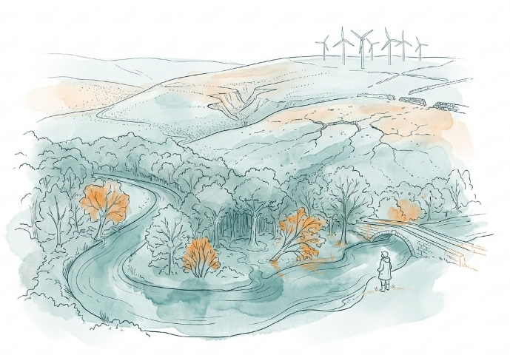
Local stakeholders report current exposure to drought and water scarcity, high water temperatures, wildfire, heavy rainfall, flooding, storms and invasive non-native species. Areas cited as seeing impacts include South Pennines and Marsden Moor, the Aire and Calder catchments, Holme Valley, north-west Leeds and waterways and reservoirs across the region.
The regional mapping shows the strongest concentration of blanket bog in western Calderdale and south-western Kirklees, with upland heathland concentrated mainly in northern and western Bradford; deciduous woodland is more dispersed across the region.⁵
The 2019 wildfire on Marsden and Castleshaw Moors damaged an estimated 666 hectares of active blanket bog. This gives clear evidence of exposure at one upland location, but available evidence does not establish what percentage of West Yorkshire’s total ecosystem area lies in present or future heat, drought, wildfire or flood hazard zones.

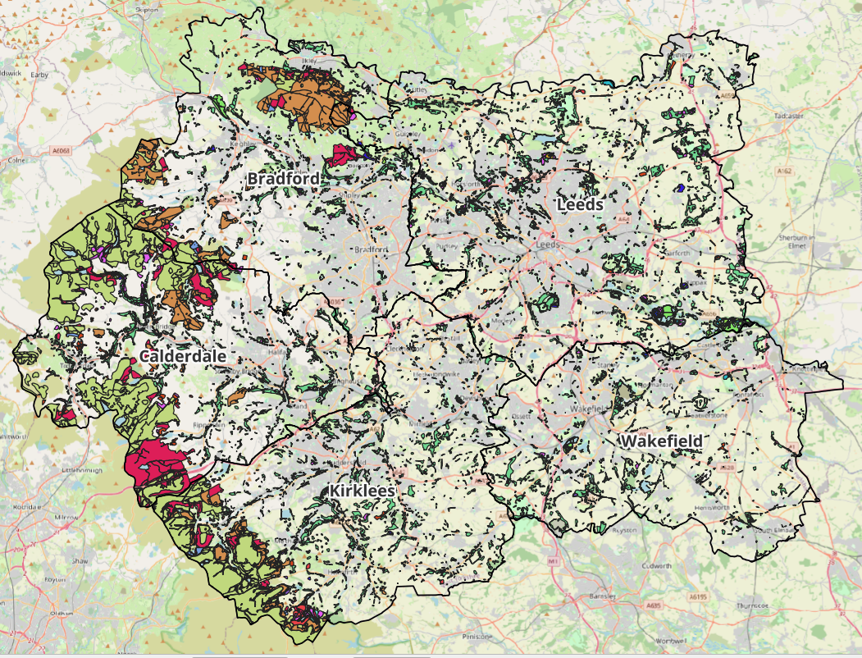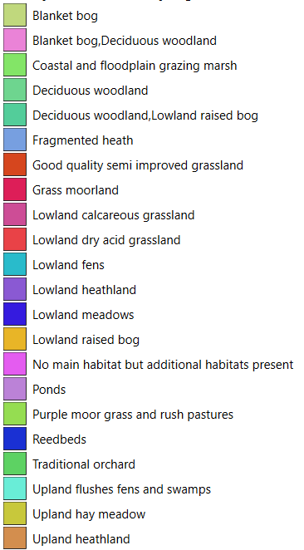
Figure 1: Priority habitats across West Yorkshire. Source: Natural England Priority Habitats Inventory, analysed for the West Yorkshire CRVA, September 2026.

Sensitivity: How significant could this risk be for the West Yorkshire region?
High
Sensitivity
The high score reflects the potential for lasting habitat loss and severe loss of ecosystem functions. Many important West Yorkshire habitats are already degraded, fragmented or in unfavourable condition. Bradford’s 2026 biodiversity report states that only 2% of its Sites of Special Scientific Interest are in favourable condition7. Although this can not be generalised to the whole region, it does indicate high sensitivity in a significant part of the South Pennine landscape.
Climate impacts could cause severe and difficult-to-reverse damage to peatland, moorland, woodland, freshwater and wetland ecosystems. The Marsden wildfire study estimated that about 11,947 tonnes of carbon were released to the atmosphere, equivalent to approximately 43,845 tonnes of carbon dioxide. An estimated 98% of the carbon loss came from peat rather than vegetation and demonstrates how one event can damage habitat, soils, carbon storage and previous restoration work at the same time. The value at risk is also substantial at this location. Survey work undertaken by the National Trust, the University of Leeds and community volunteers estimated that peat across the 2,300-hectare Marsden Moor estate stores between 1 and 1.5 million tonnes of carbon.8
Sensitivity is increased by habitat fragmentation, water dependence, poor environmental condition and repeated or compound events. Local stakeholders described drought, heat and low flows followed by heavy rainfall and pollutant wash-off, as well as restoration being damaged before it can become established. They also raised concerns about the future viability of blanket bog, ancient grassland and a fragment of temperate Atlantic rainforest.
Climate impacts could reduce carbon storage, water quality, natural flood regulation, soil stability, urban cooling, pollination and opportunities for recreation. Yorkshire Water Climate Adaptation Report also identifies risks from warmer temperatures, drier summers and wetter winters to river and reservoir water quality and upland catchments across its wider operating area.

Adaptive Capacity: Existing programmes, plans, policies, budgets and community action
Moderate
Adaptive Capacity
West Yorkshire has a strong policy, partnership, technical and community base. However, current evidence does not show that delivery is yet sufficient or secure enough to address the scale and pace of projected change.
The 2026 West Yorkshire Local Nature Recovery Strategy is the clearest region-wide framework. It includes measures to reconnect habitats, rewet peatlands, restore rivers and wetlands, improve soils, expand resilient woodland, support nature-friendly farming and increase nature in towns and cities. The West Yorkshire Climate and Environment Plan 2025-2038 also identifies a climate-resilient and nature-rich region as one of five objectives. It records investment in flood infrastructure and natural flood management and support for tree planting, urban greening and sphagnum restoration.
West Yorkshire Ecology Service provides a further element of region-wide technical capacity. It maintains the West Yorkshire Ecological Record, including designated sites, habitat networks, ecological survey material and mapped species records, and advises the five planning authorities. These records could support spatial analysis and monitoring.
District and sector capacity includes:
- Bradford reports council ecology, woodland and landscape staff; a biodiversity partnership involving more than 25 organisations; over 20 community groups; peatland restoration; wetland creation; tree planting; and £843,500 secured from the Nature Towns and Cities Fund.9
- Calderdale Ecological Emergency Action Plan 2024-30 is supported by the Wilder Calderdale partnership. It includes priorities for peatland rewetting, river and wetland reconnection, woodland and hedgerow restoration, ancient grassland recovery, vulnerable species and community action. Its objectives include protecting and improving at least 30% of Calderdale’s land, rivers and other wetlands for nature by 2030.
- Kirklees’ 2026 biodiversity report identifies continued support for White Rose Forest and community tree planting, a canopy-cover ambition, peatland restoration and nature-based solutions. It also records a £76,000 investment in the Dewsbury Country Park scheme.
- The White Rose Forest Strategic Plan 2025-2050 sets objectives for woodland expansion, habitat connectivity, sustainable management, climate resilience and community involvement across North and West Yorkshire. Delivery is intended through five-year action plans, and the strategy acknowledges that future funding will need to draw on a blend of public, private and charitable sources.
- Yorkshire Water reports upland restoration and nature-based approaches as part of a wider £8.3 billion investment programme for 2025 to 2030¹⁰.
National forestry guidance and tools provide further technical capacity. These include an adaptation practice guide, climate matching tool, ecological site classification and a structured resilience framework. They can support site-specific decisions about tree species, planting material and woodland management, but it is not clear how consistently they are yet used across West Yorkshire.
Local key stakeholders with operational insight have also identified drought, wildfire, wind exposure, shallow limestone soils, pests and disease as relevant risks. They highlighted gaps in specialist skills, site assessment, long-term woodland management and coordination across landowners.
“We need to tool people up and make them skilled technically… specialists in soil and specialists in tree species choice.”
Important gaps remain. There is no single quantified programme showing how much vulnerable habitat will be restored, connected or placed under climate-adaptive management across all five districts. Funding is spread across organisations and often short term or project-specific. Monitoring often records activities, but available evidence provides less information on whether ecosystems have become more resilient to drought, heat, wildfire, flooding, pests and disease. For these reasons, adaptive capacity is scored as moderate rather than significant or high.

Annex: Scoring Matrix
The scoring methodology uses the following formula to calculate overall vulnerability for each risk/opportunity area.
Exposure
Sensitivity
Adaptive Capacity
Overall Vulnerability
Exposure, sensitivity and adaptive capacity are scored on a scale of 0-3 (see below).

Exposure
The presence of people, livelihoods, species or ecosystems, environmental functions, services, and resources, infrastructure, or economic, social, or cultural assets in places and settings that could be adversely affected.
Score | Rating | Description | Area or System exposed
3 | High | 50-100% of affected area/system expose to climate hazards | 50-100%
2 | Significant | 25-50% of affected area/system expose to climate hazards | 25-50%
1 | Moderate | 10-25% of affected area/system expose to climate hazards | 10-25%
0 | Low or None | 0-10% of affected area/system expose to climate hazards | 0-10%

Sensitivity
The degree to which a system or species is adversely or beneficially affected by climate variability or climate change.

Score | Rating | Description
3 | High sensitivity | Potential loss of life or high impact caused by climate change. Difficult or impossible for systems to recover
2 | Significant sensitivity | If climate changes event happens, high impact, but not catastrophic
1 | Moderate sensitivity | If climate changes event happens, there is an impact, but not very disruptive
0 | None or low sensitivity | Limited or no consequence from climate event

Adaptive Capacity
The ability of current systems, institutions, structural units, humans and other organisms to adjust to potential damage, to take advantage of opportunities, or to respond to consequences
Score | Rating | Description
0 | Low or No Adaptive Capacity | Limited or no local or national policies or programmes in place to currently address specific risk/opportunity
1 | Moderate Adaptive Capacity | Either some local or national policies and programmes in place, that may indirectly address risk/opportunity or are limited in scope
2 | Significant Adaptive Capacity | Either local or national policies and programmes in place specifically addressing risk, but there are still gaps
3 | High Adaptive Capacity | Well established systems (policies, programmes) that are currently addressing this risk

Vulnerability
The final vulnerability score is calculated by adding the exposure and sensitivity scores, then subtracting the adaptive capacity score. Vulnerability is then categorised from Very High to Very Low depending on the final score.
Score | Rating
Very High | Total Score between 5 & 6
High | Total Score between 3 & 4
Medium | Total Score between 1 & 2
Low | Total Score between -1 & 0
Very Low | Total Score between -3 & -2

The detailed scoring matrix is provided in Annex: Scoring Matrix.
Local Authority Climate Report | West Yorkshire
CCRA4 Technical Report | Risks to Land, Nature and Food (2026)
The national assessment covers both terrestrial and coastal ecosystems in this risk, however for the purpose of this analysis in West Yorkshire only terrestrial ecosystems are in scope due to the region being land locked.
Nature Related Climate Risk Exposure in the West Yorkshire Combined Authority (2026)
West Yorkshire Natural Environment Stakeholder Focus Group, 9 September 2026, facilitated for the West Yorkshire Climate Risk Assessment
MoorLIFE 2020: Estimating Carbon Released from Wildfires (2021)
National Trust Press Release, July 2024
Bradford Enhanced Biodiversity Duty Report (2026)
Yorkshire Water Climate Adaptation Report (2025)
West Yorkshire Local Nature Recovery Strategy (2026)
West Yorkshire Climate and Environment Plan 2025-2038
West Yorkshire Ecology Service
Calderdale Ecological Emergency Action Plan 2024-30
Kirklees Biodiversity Duty Report (2026)
White Rose Forest Strategic Plan 2025-2050
UK Forestry Standard Adaptation Guide
Climate Matching Tool
Ecological Site Classification
Resilience Implementation Framework
Key stakeholder interview 28 August 2026, facilitated for the West Yorkshire Climate Risk Assessment

