N4: Risks to soil ecosystems

Summary vulnerability assessment
This report forms part of the West Yorkshire Combined Authority Climate Risk and Vulnerability Assessment and examines risks to soil ecosystems. Soils across the region, including upland peat, agricultural land, woodland, grassland, wetlands and urban green areas, face growing pressures from heavier rainfall, flooding, drought, heat and wildfire. The assessment rates exposure as high and sensitivity as significant because soil damage could reduce food production, biodiversity, water quality, flood regulation and carbon storage. Existing strategies, restoration programmes, partnerships and community activity provide moderate adaptive capacity, but funding, staff resources, landowner engagement, monitoring and evidence of long-term effectiveness remain insufficient for the scale and pace of projected change.
The resulting overall vulnerability rating is medium. The figure below summarises the assessment scores for exposure, sensitivity, adaptive capacity and overall vulnerability.
3
High
2
Significant
2
Moderate
3
Medium
Exposure
Sensitivity
Adaptive Capacity
Overall Vulnerability

Risk summary
Climate change is increasing pressure on soils through heavier winter rainfall, flooding, drought, heat and rapid shifts between dry and wet conditions. These hazards can increase erosion, compaction, waterlogging, carbon loss, nutrient run-off and pollution, while damaging soil organisms and reducing fertility. This can weaken food production, biodiversity, water regulation, flood resilience and carbon storage. The national assessment rates the current risk as medium, rising to high by the 2050s, but notes major gaps in monitoring and understanding of combined climate impacts.

Exposure: How exposed is West Yorkshire Combined Authority to this risk?
High
Exposure
Soil is present across almost all rural, upland, agricultural, woodland, grassland, wetland, brownfield and urban green areas of West Yorkshire. A separate regional spatial assessment carried out for this CRVA identifies 126,301 hectares of agricultural land in Grades 1 to 5, equivalent to 62% of the Combined Authority area, and 28,681 hectares of predicted peaty soil, equivalent to 14%. Figure 1 shows where peaty soils may occur; it does not show their depth, condition or exposure to individual climate hazards. Exposure is therefore geographically widespread, although the nature and severity of risk vary with soil type, condition, slope, vegetation, drainage and land management.
Local evidence identifies several areas of particular concern:
- Upland peat in the South Pennines and other moorland areas is exposed to drying, wildfire, intense rainfall and erosion. The regional mapping shows the largest connected areas of predicted peaty soil in western Calderdale and south-western Kirklees, with further concentrations in northern and western Bradford. Mapped peaty soils are more limited and fragmented across Leeds and Wakefield.³
- Agricultural land is exposed to drought, heavy rainfall, nutrient loss, erosion and compaction. National evidence indicates that erosion rates are particularly high in northern England, while the West Yorkshire natural environment stakeholder focus group for this assessment identified agriculture, floodplains and land-management systems among the assets exposed to drought and flooding.
- Contaminated and previously developed land may also be exposed. The Leeds inspection strategy confirms a substantial legacy of land contamination and a statutory system for identifying sites posing significant risks to health or the environment.

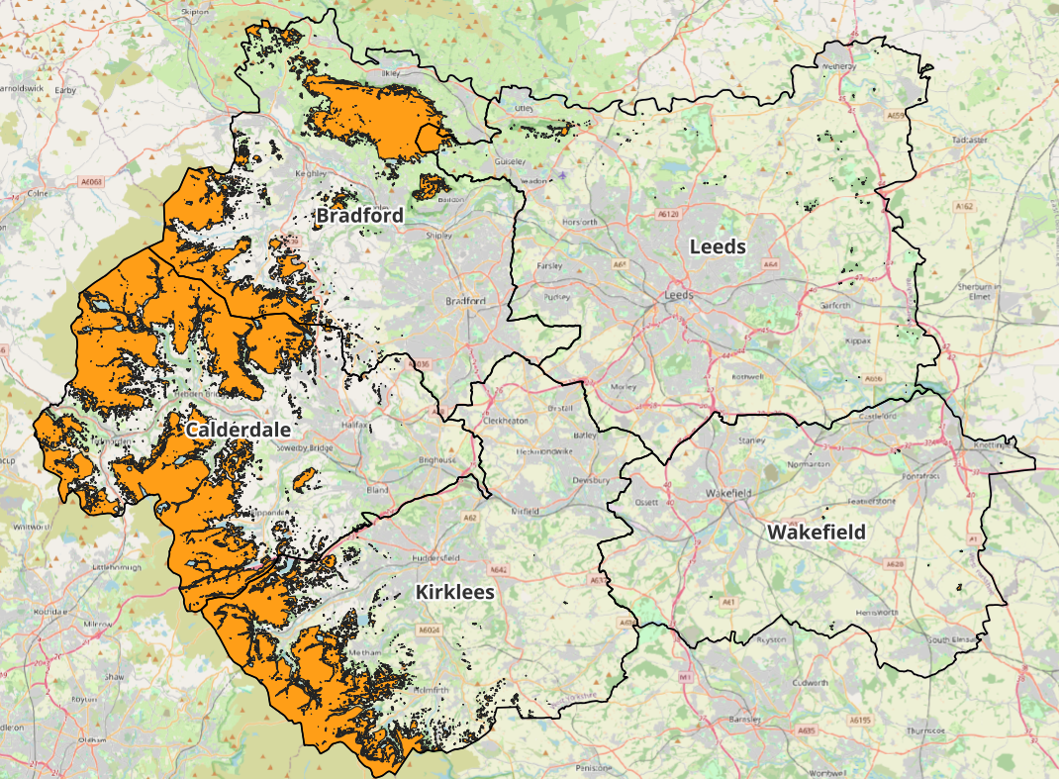
Figure 1: Predicted peaty-soil extent across West Yorkshire. Source: England Peat Map, analysed for the West Yorkshire CRVA, September 2026

Recent fires illustrate the continuing exposure of the South Pennine uplands. West Yorkshire Fire and Rescue Service recorded a large moorland fire near March Haigh Reservoir, Marsden, on 21st March 2025, requiring crews from across West Yorkshire and follow-up checks for hotspots. The incident record does not quantify peat or soil damage and does not attribute the fire to climate change, but wildfire risk is likely to increase.
The High score reflects the widespread extent of potentially affected soils, rather than a measured percentage of soils exposed to climate hazards. The regional spatial assessment³ provides a consistent baseline for agricultural land and predicted peaty-soil extent. However, it does not map all soil types or assess soil condition, and it does not overlay soils with drought, heat, wildfire, erosion or waterlogging hazards.

Sensitivity: How significant could this risk be for the West Yorkshire region?
Significant
Sensitivity
Damage to soil is likely to have important consequences for ecosystems, farming, water quality, flood management and carbon storage, but available evidence does not demonstrate region-wide catastrophic or irreversible loss.
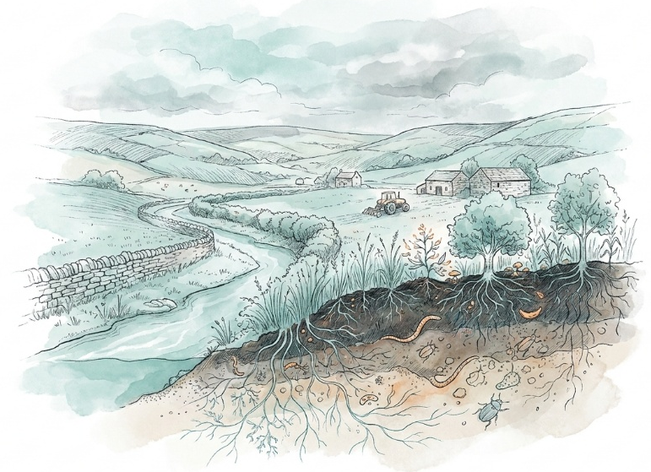
Sensitivity is likely to be greatest where soils are already degraded, compacted, drained, bare, fragmented or low in organic matter. Upland peat is particularly important because vegetation loss and drying can expose it to erosion, fire and carbon loss, particularly where peat is already exposed, in poor condition, or on artificially drained land.2 The natural environment stakeholder focus group also reported degraded upland peat, repeated fires and concern that restoration may not establish before another extreme event.⁴
Wakefield’s habitat information illustrates local sensitivity. Many valuable habitats are small or fragmented, including Magnesian Limestone grassland, neutral and acid grasslands, heathland, wetland and woodland. The Local Biodiversity Plan identifies development, lack of management, pollution and fragmentation as existing pressures. Such habitats may have less capacity to absorb additional soil degradation or support species movement.
There is also potential for compound impacts. Soil erosion and nutrient run-off can affect water quality; soil carbon loss can increase greenhouse gas emissions; and damaged soil structure can reduce water infiltration and increase downstream flood risk. West Yorkshire stakeholders specifically described repeated drought, wildfire and flooding, and rapid switches between drought and storms, but did not quantify their probability or ecological thresholds.⁴

Adaptive Capacity: Existing programmes, plans, policies, budgets and community action
Moderate
Adaptive Capacity
West Yorkshire has relevant strategies, delivery programmes, partnerships, skills and community activity, but these do not yet amount to a comprehensive, monitored soil adaptation system.
The strongest strategic framework is the West Yorkshire Local Nature Recovery Strategy. Published in 2026, it includes priorities and measures for farmland, grasslands, trees and woodland, uplands, water and wetlands, and a specific priority for healthy, biodiverse soils. It is accompanied by a habitat map showing where measures could take place. However, the strategy notes that mapped actions do not themselves provide permission or ensure delivery.
The West Yorkshire Climate and Environment Plan includes a climate-resilient and nature-rich objective and records investment in flood resilience, natural flood management and development of the Local Nature Recovery Strategy. It provides an enabling regional framework, but does not identify dedicated soil adaptation work.
Several programmes provide practical capacity, regionally and nationally:
- Landscapes for Water is restoring degraded upland land around Marsden Moor using pools, natural flood-management dams, bank-stabilising structures and community activities. It is led by the West Yorkshire Combined Authority and the National Trust and has £1.984 million of Devolution Gainshare funding. Work began in August 2023 and is expected to finish in March 2028.
- The West Yorkshire Flood Innovation Programme brings together the five Lead Local Flood Authorities, the Environment Agency, the Combined Authority, researchers, community groups and other partners. It works across catchments and administrative boundaries and supports research, shared learning and natural approaches to flood resilience.
- The Natural England adaptation plan sets out actions to improve how climate risks are managed through its work up to the end of 2029, providing relevant national institutional capacity.
Community and partnership capacity is also evident. Wakefield’s older biodiversity plan records local conservation groups, “Friends” groups, habitat restoration, wildlife monitoring and advice for landowners.⁸ The natural environment stakeholder focus-group evidence identifies continuing natural flood management, peatland restoration, tree planting, wetland proposals and cross-sector collaboration.⁴ However, stakeholders also reported limited finance and staff time, difficulty sustaining preventative work, uneven landowner engagement, weak knowledge sharing and concern that repeated extremes may damage restoration before it becomes established.
The moderate score recognises that relevant policies, projects, partnerships and skills exist. It is not rated significant because current evidence does not establish their total geographic coverage, long-term funding, effectiveness in improving soil condition, or whether activity matches the scale of the projected risk.

Annex: Scoring Matrix
The scoring methodology uses the following formula to calculate overall vulnerability for each risk/opportunity area.
Exposure
Sensitivity
Adaptive Capacity
Overall Vulnerability
Exposure, sensitivity and adaptive capacity are scored on a scale of 0-3 (see below).

Exposure
The presence of people, livelihoods, species or ecosystems, environmental functions, services, and resources, infrastructure, or economic, social, or cultural assets in places and settings that could be adversely affected.
Score | Rating | Description | Area or System exposed
3 | High | 50-100% of affected area/system expose to climate hazards | 50-100%
2 | Significant | 25-50% of affected area/system expose to climate hazards | 25-50%
1 | Moderate | 10-25% of affected area/system expose to climate hazards | 10-25%
0 | Low or None | 0-10% of affected area/system expose to climate hazards | 0-10%

Sensitivity
The degree to which a system or species is adversely or beneficially affected by climate variability or climate change.

Score | Rating | Description
3 | High sensitivity | Potential loss of life or high impact caused by climate change. Difficult or impossible for systems to recover
2 | Significant sensitivity | If climate changes event happens, high impact, but not catastrophic
1 | Moderate sensitivity | If climate changes event happens, there is an impact, but not very disruptive
0 | None or low sensitivity | Limited or no consequence from climate event

Adaptive Capacity
The ability of current systems, institutions, structural units, humans and other organisms to adjust to potential damage, to take advantage of opportunities, or to respond to consequences
Score | Rating | Description
0 | Low or No Adaptive Capacity | Limited or no local or national policies or programmes in place to currently address specific risk/opportunity
1 | Moderate Adaptive Capacity | Either some local or national policies and programmes in place, that may indirectly address risk/opportunity or are limited in scope
2 | Significant Adaptive Capacity | Either local or national policies and programmes in place specifically addressing risk, but there are still gaps
3 | High Adaptive Capacity | Well established systems (policies, programmes) that are currently addressing this risk

Vulnerability
The final vulnerability score is calculated by adding the exposure and sensitivity scores, then subtracting the adaptive capacity score. Vulnerability is then categorised from Very High to Very Low depending on the final score.
Score | Rating
Very High | Total Score between 5 & 6
High | Total Score between 3 & 4
Medium | Total Score between 1 & 2
Low | Total Score between -1 & 0
Very Low | Total Score between -3 & -2

The detailed scoring matrix is provided in Annex: Scoring Matrix.
Chapter 5: Land, Nature, and Food - UK Climate Risk
Nature Related Climate Risk Exposure in the West Yorkshire Combined Authority (2026)
West Yorkshire Natural Environment Stakeholder Focus Group, 9 September 2026, facilitated for the West Yorkshire Climate Risk Assessment
Inspection Strategy for Leeds
West Yorks Fire Service - incident report
Wakefield Local Biodiversity Action Plan (2014)
West Yorkshire Local Nature Recovery Strategy (2026)
West Yorkshire Climate and Environment Plan 2025-2038
West Yorkshire Flood Innovation Programme
Natural England Climate Change Adaptation Plan - update (2025)

