N5: Risks to natural carbon stores and sequestration

Summary vulnerability assessment
This report forms part of the West Yorkshire Combined Authority Climate Risk and Vulnerability Assessment and examines risks to natural carbon stores and sequestration. West Yorkshire’s peat, soils, woodland, trees and other semi-natural habitats store significant carbon and help remove further carbon dioxide from the atmosphere. These assets face growing pressures from hotter and drier periods, wildfire, heavy rainfall, erosion, storms, pests and disease, alongside existing pressures from drainage, pollution, habitat fragmentation and land management. The assessment rates exposure as moderate and sensitivity as significant because climate change could damage important carbon stores, reduce sequestration and weaken wider benefits for biodiversity, water regulation, flood management and landscape resilience. Existing policies, partnerships and restoration programmes provide moderate adaptive capacity, but coverage, secure long-term funding, outcome monitoring and coordination remain insufficient for the scale and pace of projected change.
The resulting overall vulnerability rating is medium. The figure below summarises the assessment scores for exposure, sensitivity, adaptive capacity and overall vulnerability.
1
Moderate
2
Significant
1
Moderate
2
Medium
Exposure
Sensitivity
Adaptive Capacity
Overall Vulnerability

Risk summary
Climate change threatens the carbon stored in West Yorkshire’s peat, soils, trees, woodland and other semi-natural habitats. It also threatens their ability to remove further carbon dioxide from the atmosphere. Hotter and drier periods can dry peat and soils, stress or kill trees and increase wildfire risk. Heavy rainfall can erode exposed peat and soils, while storms, pests and diseases can damage woodland. These pressures interact with drainage, pollution, habitat fragmentation and unsuitable land management. Degraded habitats can change from carbon sinks into carbon sources. This can also weaken biodiversity, water regulation, flood management and landscape resilience. The national Climate Change Risk Assessment rates this risk as High in England at present, in the 2030s and in the 2050s, rising to Very High by the 2080s. It concludes that more action is needed.

Exposure: How exposed is West Yorkshire Combined Authority to this risk?
Moderate
Exposure
Peaty soils cover 28,681 hectares, equivalent to 14% of the West Yorkshire Combined Authority area. They are concentrated across the uplands of western Calderdale and south-western Kirklees, with further concentrations in northern and western Bradford. Peaty soils are more limited and fragmented in Leeds and Wakefield. This places the mapped peat resource within the Moderate exposure band of 10% to 25% of the regional area1.
Exposure extends beyond mapped peat. Priority habitats cover 44,768 hectares, or 22% of West Yorkshire. Blanket bog accounts for 43% of this priority-habitat area and deciduous woodland accounts for a further 27.46%4. The highest modelled total carbon-storage values broadly follow the western uplands and peaty soils. Other stores, particularly woodland and vegetation, are more widely distributed across Bradford, Leeds, Kirklees and Wakefield.
The map below uses Natural England’s Spatial Prioritisation of Total Carbon Storage 2023 dataset to show the broad distribution of carbon stored in soils and vegetation. It maps modelled carbon stocks at a 25-metre resolution and is intended for strategic comparison and prioritisation. Areas above 375 tonnes of carbon per hectare are shown to highlight the region’s larger existing stores. The highest values occur in western Calderdale and south-western Kirklees, broadly matching the main areas of peaty soil, while smaller areas across Bradford, Leeds, Kirklees and Wakefield reflect carbon held in woodland and other vegetation. These areas indicate where larger carbon stores may be exposed to wildfire, drought, erosion, storms, pests, disease and land-use pressures. However, it is also important to note that the map shows stored carbon rather than sequestration rates, habitat condition, future carbon uptake or likely carbon loss.

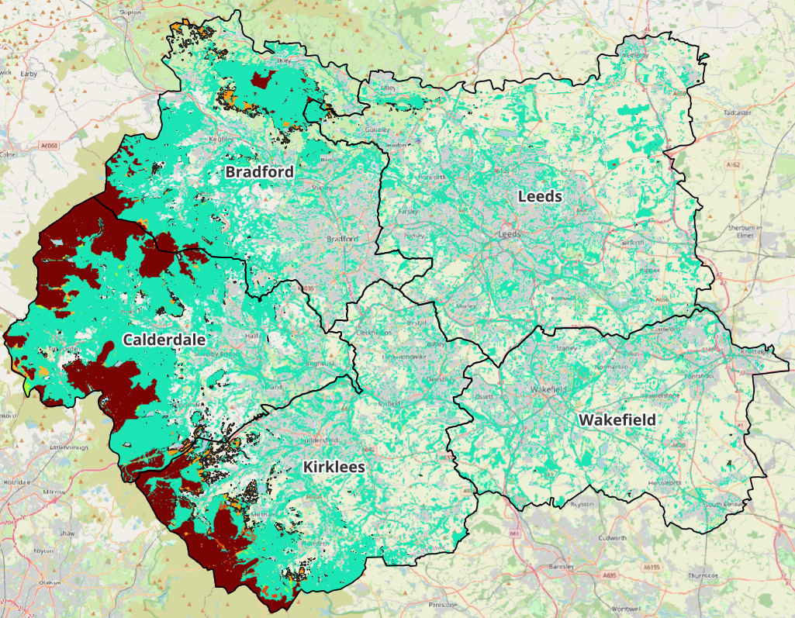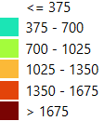
Figure 1: Total Carbon Storage (Carbon Tonne ha/yr) across the West Yorkshire Combined Authority. Source: Natural England Open Data Geoportal
Local evidence demonstrates the potential scale of loss of carbon stores at individual sites. The April 2019 wildfire on Marsden and Castleshaw Moors damaged about 666 hectares of active blanket bog. The study estimated that 11,946.74 tonnes of carbon reached the atmosphere, with 98% of the carbon loss originating from peat. It also converted the estimated loss to 43,844 tonnes of carbon dioxide. The calculation assumed a uniform burn depth across the affected area, although fire severity varied, so the estimate should be treated with caution.
Research reported by the National Trust estimated that the 2,300-hectare Marsden Moor estate stores between one and 1.5 million tonnes of carbon. This estimate was based on peat-depth measurements at 2,290 locations, although further analysis of bulk density and carbon content was continuing when the results were published in July 2024.

Sensitivity: How significant could this risk be for the West Yorkshire region?
Significant
Sensitivity
Carbon held in deep peat and long-established habitats may have accumulated over centuries or millennia. Losses can therefore be difficult to reverse. Healthy peatlands can continue to accumulate carbon, but drying and drainage allow stored organic matter to decompose and release greenhouse gases. Wildfire can cause rapid carbon loss and can damage restoration work before vegetation and hydrology have recovered.
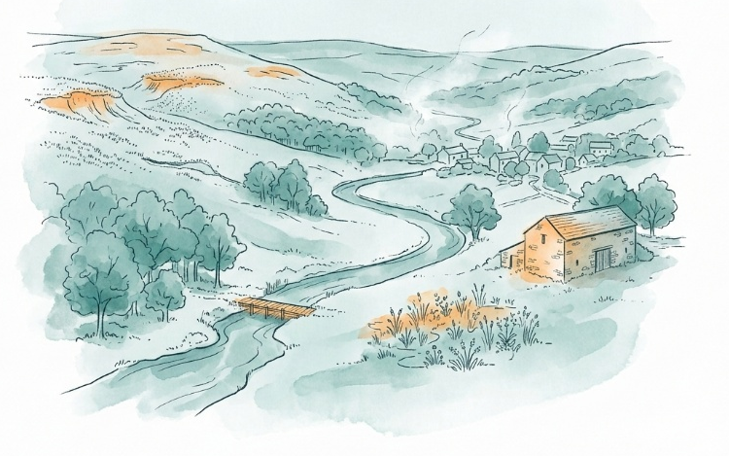
The sensitivity of individual sites depends strongly on habitat condition and management. Natural England states that management, condition, vegetation age, soil type, hydrology and slope affect carbon storage and sequestration. It identifies maintaining and enhancing existing peatland habitat as the most important action where peat and appropriate natural habitat coincide. Where peat is beneath grassland or arable land, restoring wetter natural habitat can reduce continued carbon loss.
Woodlands are also sensitive. Drought, storms, tree mortality, pests, disease and poor regeneration can reduce carbon uptake and threaten existing stores. Key sector stakeholders interviewed during this assessment identified drought and wildfire as important recent pressures in West Yorkshire. They also warned that policies may assume woodland will deliver carbon, flood-management and cooling benefits without assessing whether the woodland itself is resilient to climate change.
The consequences would extend beyond greenhouse gas emissions. Peat degradation can increase erosion, reduce water retention and damage habitat. Woodland decline can affect biodiversity, water management, recreation and the supply of timber and other materials.
Wildfires at Marsden Moor have continued since 2019. West Yorkshire Fire and Rescue Service recorded a major incident near March Haigh Reservoir on 21 March 2025, fires at Deer Hill and Five Mile Post on 7 April 2026, and a further fire near Wessenden Reservoir from 23 to 25 July 2026. These incidents demonstrate repeated pressure on the same high-carbon upland landscape and on firefighting and restoration capacity.
The available evidence supports Significant rather than High sensitivity at regional scale, with potentially severe impacts at individual high-carbon sites.

Adaptive Capacity: Existing programmes, plans, policies, budgets and community action
Moderate
Adaptive Capacity
West Yorkshire has relevant policies, funded projects, delivery partnerships and technical tools. These provide a sound basis for protecting and restoring natural carbon stores. However, currently available evidence has not demonstrated a comprehensive, securely funded and monitored response across the whole region.
- Policies and plans: The West Yorkshire Climate and Environment Plan 2025-2038 includes creating a climate-resilient and nature-rich region as one of its five objectives. It records support for tree planting through the White Rose Forest, urban greening and the Calderdale sphagnum project. The West Yorkshire Local Nature Recovery Strategy adds spatial priorities for high-quality peatlands, resilient trees and woodland, healthy soils and wetlands. Its proposed monitoring targets include increasing the area of rewetted peatland and tree-canopy cover. These plans provide strategic direction, but they do not by themselves guarantee funding, landowner participation or delivery at individual sites.
- Programmes, funding and community action: The Landscapes for Water project is restoring degraded uplands around Marsden Moor through pools, natural flood-management dams, bank stabilisation and community events. The project received £1.984 million of Devolution Gainshare funding and is expected to run from August 2023 to March 2028. Its aims include reducing erosion and carbon loss, restoring habitats and improving climate resilience. The White Rose Forest Action Plan also supports woodland establishment, sustainable management, public engagement and stronger policy alignment, although it states that delivery depends on funding, staff capacity and partner support.
- In Bradford District, the Ilkley Moor Resilience project provides a further example of active peatland adaptation. Works begun in 2024 include gully blocking, sphagnum planting, heather management, Sitka spruce removal and access-route management. The project is establishing evidence on hydrology, biodiversity and carbon and includes monitoring of restoration measures. Reported delivery to April 2025 included 31,000 sphagnum plugs, 415 gully dams and 36.2 hectares of Sitka spruce removal.
- Wider peatland delivery capacity: As of the end of March 2025, the Yorkshire Peat Partnership Annual Report reported 51,867 hectares of peat-restoration work since 2009 across its wider operational area. During 2024/25, it reported work across 7,689 hectares and secured £1,706,299 for core costs and £1,510,000 for direct restoration. These figures demonstrate substantial specialist skills and access to funding across Yorkshire, but they should not be treated as West Yorkshire totals. The report records 2,028 hectares of completed walkover surveys in the South Pennines by March 2025.
Overall, the region has meaningful strategic, financial and technical capacity. The main gaps are uneven geographic coverage, uncertainty over long-term funding, limited evidence of outcomes, and the absence of consistent monitoring linking restoration and woodland management to changes in carbon storage, sequestration and climate resilience.

Annex: Scoring Matrix
The scoring methodology uses the following formula to calculate overall vulnerability for each risk/opportunity area.
Exposure
Sensitivity
Adaptive Capacity
Overall Vulnerability
Exposure, sensitivity and adaptive capacity are scored on a scale of 0-3 (see below).

Exposure
The presence of people, livelihoods, species or ecosystems, environmental functions, services, and resources, infrastructure, or economic, social, or cultural assets in places and settings that could be adversely affected.
Score | Rating | Description | Area or System exposed
3 | High | 50-100% of affected area/system expose to climate hazards | 50-100%
2 | Significant | 25-50% of affected area/system expose to climate hazards | 25-50%
1 | Moderate | 10-25% of affected area/system expose to climate hazards | 10-25%
0 | Low or None | 0-10% of affected area/system expose to climate hazards | 0-10%

Sensitivity
The degree to which a system or species is adversely or beneficially affected by climate variability or climate change.

Score | Rating | Description
3 | High sensitivity | Potential loss of life or high impact caused by climate change. Difficult or impossible for systems to recover
2 | Significant sensitivity | If climate changes event happens, high impact, but not catastrophic
1 | Moderate sensitivity | If climate changes event happens, there is an impact, but not very disruptive
0 | None or low sensitivity | Limited or no consequence from climate event

Adaptive Capacity
The ability of current systems, institutions, structural units, humans and other organisms to adjust to potential damage, to take advantage of opportunities, or to respond to consequences
Score | Rating | Description
0 | Low or No Adaptive Capacity | Limited or no local or national policies or programmes in place to currently address specific risk/opportunity
1 | Moderate Adaptive Capacity | Either some local or national policies and programmes in place, that may indirectly address risk/opportunity or are limited in scope
2 | Significant Adaptive Capacity | Either local or national policies and programmes in place specifically addressing risk, but there are still gaps
3 | High Adaptive Capacity | Well established systems (policies, programmes) that are currently addressing this risk

Vulnerability
The final vulnerability score is calculated by adding the exposure and sensitivity scores, then subtracting the adaptive capacity score. Vulnerability is then categorised from Very High to Very Low depending on the final score.
Score | Rating
Very High | Total Score between 5 & 6
High | Total Score between 3 & 4
Medium | Total Score between 1 & 2
Low | Total Score between -1 & 0
Very Low | Total Score between -3 & -2

The detailed scoring matrix is provided in Annex: Scoring Matrix.
Local Authority Climate Report | West Yorkshire
Chapter 5: Land, Nature, and Food - UK Climate Risk
Nature Related Climate Risk Exposure in the West Yorkshire Combined Authority (2026)
Spatial Prioritisation of Total Carbon Storage 2023 (England) | Natural England Open Data Geoportal
Estimation of the amount of carbon released as a result of Marsden wildfire | Moors for the Future (2019)
National Trust press release (2024)
NECR510 Edition 1 Spatial Prioritisation of Land Management for Carbon Dataset (2023)
Key stakeholder interview 24th August 2026, facilitated for the West Yorkshire Climate Risk Assessment
West Yorks Fire Service - incident report
West Yorkshire Climate and Environment Plan 2025-2038
West Yorkshire Local Nature Recovery Strategy (2026)
Landscapes for Water
White Rose Forest Action Plan 2026-2031
Ilkley Moor Resilience
Yorkshire Peat Partnership Annual Report 2024–2025

