N6: Risks to agriculture

Summary vulnerability assessment
This report forms part of the West Yorkshire Combined Authority Climate Risk and Vulnerability Assessment and examines risks to agriculture. Agricultural land covers much of West Yorkshire and faces growing pressures from heat, drought, flooding, waterlogging, soil erosion, wildfire, pests, disease and livestock heat stress. The assessment rates exposure as significant and sensitivity as high because climate change could reduce crop and livestock productivity, damage soils, disrupt planting and harvesting, increase costs and affect farm incomes, animal welfare and local supply chains. National and regional policies, funding schemes and practical farm measures provide significant adaptive capacity, but uptake, coordination, advice, finance and evidence of effectiveness remain insufficient for the scale and pace of projected change.
The resulting overall vulnerability rating is medium. The figure below summarises the assessment scores for exposure, sensitivity, adaptive capacity and overall vulnerability.
3
High
2
Significant
2
Significant
3
Medium
Exposure
Sensitivity
Adaptive Capacity
Overall Vulnerability

Risk summary
Climate change is already affecting agriculture through rising temperatures, changing rainfall, drought, flooding, soil degradation, pests, diseases and livestock heat stress. These pressures can reduce crop and livestock productivity, disrupt planting and harvesting, damage soils and increase costs. National evidence rates the present risk to agriculture in England as High, remaining High in the 2030s and 2050s and increasing to Very high by the 2080s. It concludes that more action is needed because existing policies recognise the risk, but there is limited evidence that action is reducing it effectively.
For West Yorkshire, the main concerns are increasingly variable water availability, waterlogged land, drought, heat stress, soil erosion and runoff, wildfire risk in upland farming areas, and changing pest and disease pressures. These hazards may occur in sequence or together. For example, a wet winter may delay planting and damage soils, followed by a dry summer that limits crop establishment, grass growth and water supplies.
The 2025 drought provides a recent illustration of this variability. England experienced its driest spring since 1893 and hottest summer on record, following an exceptionally wet period up to December 2024. By the end of summer, reservoirs across Yorkshire and the Pennines were very low and farmers faced severe challenges.

Exposure: How exposed is West Yorkshire Combined Authority to this risk?
High
Exposure
Separate analysis produced for this assessment finds that agricultural land in Grades 1 to 5 covers 126,301 hectares, equivalent to 62% of the West Yorkshire Combined Authority area. The High score reflects the large extent of agricultural land that could potentially be affected. The 62% figure measures the presence of the receptor, rather than the proportion currently or subsequently exposed to a defined drought, flood, heat or wildfire threshold. Hazard-specific exposure remains less certain.
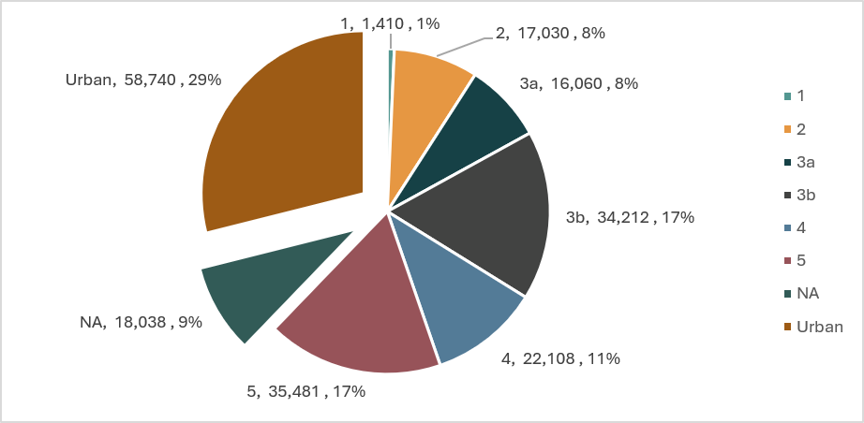
Figure 1: Predictive Agricultural Land Classification for the West Yorkshire Combined Authority by grades

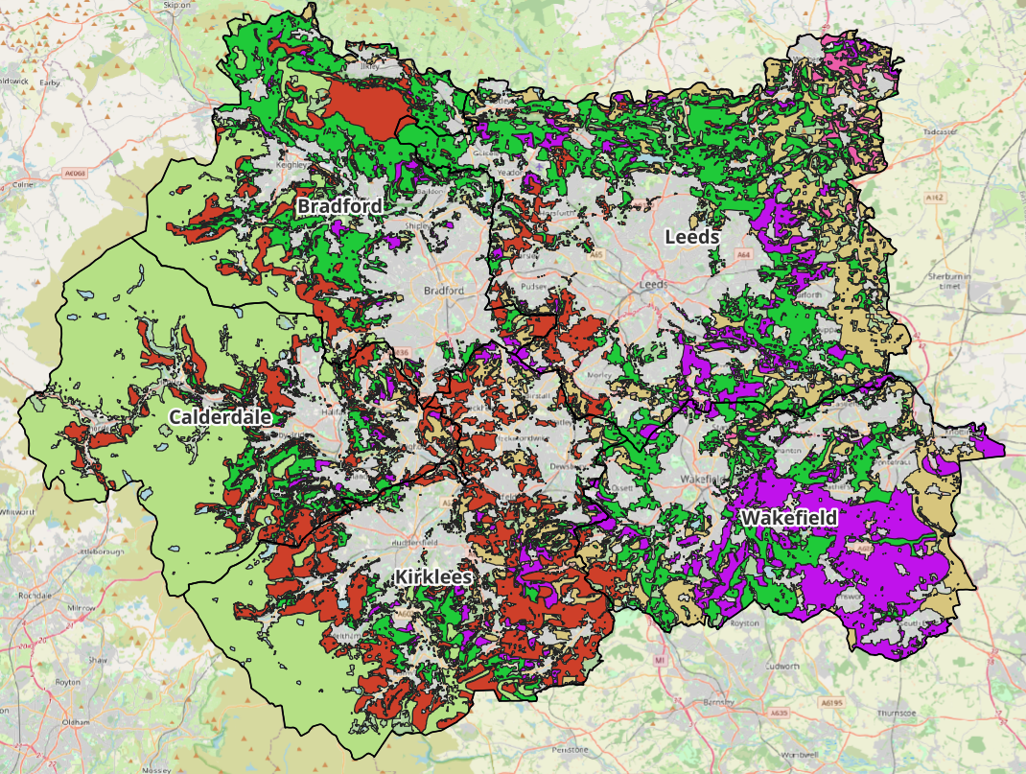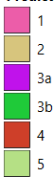
Figure 2: Predictive Agricultural Land Classification for the West Yorkshire Combined Authority

The best and most versatile agricultural land, comprising Grades 1, 2 and 3a, covers 34,500 hectares or 16.99% of the region. Grade 1 land is limited to 1,410 hectares, or 0.69% of the regional area. These figures show extensive exposure of agricultural land, although the classification indicates land quality rather than current production, farm type or vulnerability to individual hazards.
Exposure differs across west Yorkshire. Upland farms in western Calderdale, Kirklees and Bradford are likely to face risks associated with wet soils, intense rainfall, drought, wildfire and changing grass growth. Lower-lying agricultural land in Leeds and Wakefield may be particularly exposed to river and surface-water flooding, waterlogging and soil erosion (see Figure 2). This broad pattern is supported by local stakeholder evidence, but current evidence does not provide a complete map of farm enterprises, livestock, crops or water sources across the five districts. The Natural Environment Focus Group for this assessment identified agricultural land and food production as exposed to drought, water scarcity, heavy rainfall and flooding, while also recording concerns about soil condition, runoff and farmer and landowner engagement.
Representatives of the agricultural sector reported to this assessment that farmers are already experiencing hotter, drier summers, warmer, wetter winters, flooding, drought and new disease challenges. Water availability and flooding were identified as the most prominent current concerns. They also identified irrigation-dependent arable and horticultural systems, water-demanding crops such as potatoes, and livestock farms relying on boreholes as particularly exposed.

Sensitivity: How significant could this risk be for the West Yorkshire region?
Significant
Sensitivity
Climate impacts could cause substantial losses and disruption to individual farms, with consequences for farm income, livestock welfare, rural livelihoods and local supply chains. However, available evidence does not demonstrate that agriculture across West Yorkshire as a whole would face irreversible or catastrophic failure.
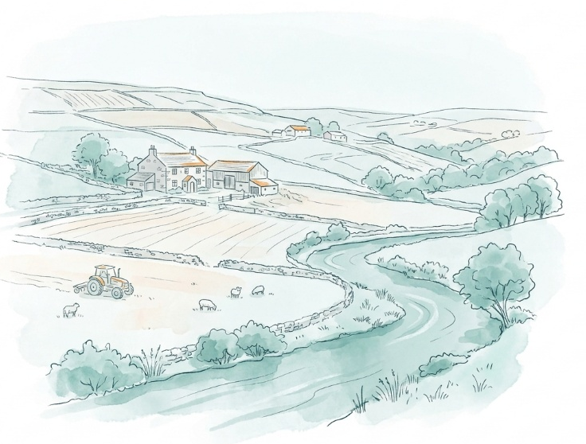
Agriculture is inherently sensitive because production depends heavily on soil, water and weather. Nationally, nearly 99% of United Kingdom agricultural production relies on soil.² Climate change threatens this resource through erosion, compaction, flooding, drought, declining organic matter and biodiversity loss. Drought, heat and extreme rainfall can reduce productivity while worsening soil condition, runoff and freshwater pollution. The effects can also interact with declining pollinators, pest regulation, food security and land-based carbon storage.
The national assessment provides evidence of the scale of possible disruption. Wet conditions contributed to a 20% reduction in United Kingdom wheat production in 2024 compared with 2023. Record temperatures in summer 2022 reduced poultry production and increased premature poultry deaths in housing and transport. England’s present agricultural risk is assessed as High because climate impacts have caused major and frequent damage and economic losses of hundreds of millions of pounds.
Different West Yorkshire farming systems will have different sensitivities:
- Arable and horticultural production: drought, heat and lack of irrigation can prevent crop establishment or damage crops during critical growth stages. Wetter winters can restrict access to fields, delay sowing and increase compaction. Agricultural sector representatives interviewed during this assessment identified arable and horticulture as particularly sensitive.⁷
- Livestock farming: heat can reduce feed intake, fertility, growth and milk production. Drought can limit grass and forage, while flooding can restrict livestock movement and contaminate feed or water. Technical guidance recommends reliable clean water, shade, ventilation and evacuation planning, demonstrating the practical sensitivity of cattle and sheep systems to extreme weather.
- Upland farming: drought and changes in vegetation management may interact with wildfire risk. Agricultural sector representatives interviewed during this assessment raised increasing wildfire concerns in upland areas and the possible role of vegetation or “fuel” accumulation, but this represents a stakeholder view and has not been independently quantified for West Yorkshire.⁷
- Potato and other susceptible crops: the national assessment projects potato-blight frequency rising by 20% to 30% by 2070 in areas including Yorkshire as a whole.
Financial resilience could increase or reduce sensitivity. Wider Yorkshire and the Humber statistics show that average Farm Business Income across all farm types fell by 43% between 2022/23 and 2023/24. Grazing-livestock farms recorded lower average income than cereal farms in 2023/24. These statistics relate to the much larger Yorkshire and the Humber region, have wide confidence intervals and exclude smaller farms below the survey threshold. They indicate potential financial pressure but do not measure the financial resilience of West Yorkshire farms.
Some opportunities may arise from warmer average conditions, including altered growing seasons and the potential suitability of different crops. However, national analysis highlights uncertainty about apparently beneficial average yield projections because more frequent and unpredictable extreme events may offset them.² New crops must also be suited to local soils, rainfall, pests and pathogens.

Adaptive Capacity: Existing programmes, plans, policies, budgets and community action
Significant
Adaptive Capacity
Relevant policies, programmes and practical adaptation measures exist, but current evidence does not show that they are sufficiently coordinated, funded or widely adopted to manage the risk across West Yorkshire.
At national level, Environmental Land Management schemes support measures such as environmental restoration, changes in farming practice and agroforestry. The Third National Adaptation Programme includes measures to support more climate-resilient crop varieties and farmed animals, £10 million for on-farm reservoirs and irrigation infrastructure, and an investment of up to around £30 million in precision-breeding research.
England’s Environmental Improvement Plan includes an initial £10 million investment in on-farm water storage and an ambition to increase storage capacity by 66% by 2050. However, the national CCRA4 concludes that the United Kingdom still lacks a targeted strategy and measurable targets for maintaining agricultural productivity as the climate changes.²
At regional level, West Yorkshire Climate and Environment Plan supports regenerative agriculture, landowner engagement, nature recovery, natural flood management and improved water management. The West Yorkshire Local Nature Recovery Strategy complements this through priorities for nature-friendly farming, healthy soils, hedgerows, field margins and biodiverse catchments and floodplains. These frameworks create opportunities to improve agricultural resilience, but delivery depends on voluntary landowner participation, suitable advice, funding and measures that remain compatible with viable farm businesses.
Practical farm-level options include on-farm reservoirs, efficient irrigation, reliable emergency water supplies, deeper-rooted grasses and drought-tolerant forage, better soil management, livestock shade and ventilation, and flood or extreme-weather plans. Natural flood-management measures, including soil aeration, tree planting and hedgerows, are already being used in parts of the Aire catchment. However, current evidence does not establish how widely these measures have been adopted across the five West Yorkshire districts or whether they are reducing agricultural losses.
Farmer engagement and peer learning could also strengthen adaptive capacity. The Yorkshire Sustainable Landscapes Programme provided soil testing, cover-crop support, technical advice and opportunities for farmers to learn from one another. Participating farmers reported greater use of cover crops, less fertiliser and reduced cultivation. The evaluation covered a small, self-selecting group in pilot areas outside West Yorkshire, so it provides a potentially transferable model rather than evidence of region-wide capacity.
Important barriers remain. Farmers may prioritise short-term financial stability, lack information about the relative costs and benefits of adaptation, or regard climate risks as uncertain or distant. There is no complete West Yorkshire inventory of farm preparedness, investment or adaptation uptake. Adaptive capacity is therefore assessed as Significant, rather than High.

Annex: Scoring Matrix
The scoring methodology uses the following formula to calculate overall vulnerability for each risk/opportunity area.
Exposure
Sensitivity
Adaptive Capacity
Overall Vulnerability
Exposure, sensitivity and adaptive capacity are scored on a scale of 0-3 (see below).

Exposure
The presence of people, livelihoods, species or ecosystems, environmental functions, services, and resources, infrastructure, or economic, social, or cultural assets in places and settings that could be adversely affected.
Score | Rating | Description | Area or System exposed
3 | High | 50-100% of affected area/system expose to climate hazards | 50-100%
2 | Significant | 25-50% of affected area/system expose to climate hazards | 25-50%
1 | Moderate | 10-25% of affected area/system expose to climate hazards | 10-25%
0 | Low or None | 0-10% of affected area/system expose to climate hazards | 0-10%

Sensitivity
The degree to which a system or species is adversely or beneficially affected by climate variability or climate change.

Score | Rating | Description
3 | High sensitivity | Potential loss of life or high impact caused by climate change. Difficult or impossible for systems to recover
2 | Significant sensitivity | If climate changes event happens, high impact, but not catastrophic
1 | Moderate sensitivity | If climate changes event happens, there is an impact, but not very disruptive
0 | None or low sensitivity | Limited or no consequence from climate event

Adaptive Capacity
The ability of current systems, institutions, structural units, humans and other organisms to adjust to potential damage, to take advantage of opportunities, or to respond to consequences
Score | Rating | Description
0 | Low or No Adaptive Capacity | Limited or no local or national policies or programmes in place to currently address specific risk/opportunity
1 | Moderate Adaptive Capacity | Either some local or national policies and programmes in place, that may indirectly address risk/opportunity or are limited in scope
2 | Significant Adaptive Capacity | Either local or national policies and programmes in place specifically addressing risk, but there are still gaps
3 | High Adaptive Capacity | Well established systems (policies, programmes) that are currently addressing this risk

Vulnerability
The final vulnerability score is calculated by adding the exposure and sensitivity scores, then subtracting the adaptive capacity score. Vulnerability is then categorised from Very High to Very Low depending on the final score.
Score | Rating
Very High | Total Score between 5 & 6
High | Total Score between 3 & 4
Medium | Total Score between 1 & 2
Low | Total Score between -1 & 0
Very Low | Total Score between -3 & -2

The detailed scoring matrix is provided in Annex: Scoring Matrix.
Chapter 5: Land, Nature, and Food - UK Climate Risk
Local Authority Climate Report | West Yorkshire
Nature Related Climate Risk Exposure in the West Yorkshire Combined Authority (2026)
West Yorkshire Natural Environment Stakeholder Focus Group, 9 September 2026, facilitated for the West Yorkshire Climate Risk Assessment
Key stakeholder interview 17 August 2026, facilitated for the West Yorkshire Climate Risk Assessment
Managing Cattle and Sheep During Extreme Weather Events | Agriculture & Horticulture Development Board
Gov UK Official Statistics, Agricultural facts: Yorkshire and the Humber region
Third National Adaptation Programme (NAP3) - GOV.UK
West Yorkshire Climate and Environment Plan 2025-2038
West Yorkshire Local Nature Recovery Strategy (2026)
Evaluation of Yorkshire Sustainable Landscapes Programme (2021)

