N7: Risks to fisheries and aquaculture

Summary vulnerability assessment
This report forms part of the West Yorkshire Combined Authority Climate Risk and Vulnerability Assessment and examines risks to fisheries and aquaculture. West Yorkshire’s rivers, canals, reservoirs, ponds and angling waters face growing pressures from warmer water, drought, low flows, reduced dissolved oxygen, flooding, pollution, disease and invasive non-native species. The assessment rates exposure as moderate and sensitivity as significant because these pressures could cause fish deaths, disrupt breeding, alter species composition and damage recreational fisheries. Existing strategies, regulation, partnerships, monitoring and river restoration provide some adaptive capacity, but action remains fragmented and there is no regional inventory, consistent monitoring programme or dedicated fisheries climate adaptation plan.
The resulting overall vulnerability rating is medium. The figure below summarises the assessment scores for exposure, sensitivity, adaptive capacity and overall vulnerability.
1
Moderate
2
Significant
1
Moderate
2
Medium
Exposure
Sensitivity
Adaptive Capacity
Overall Vulnerability

Risk summary
Climate change could affect West Yorkshire’s fish populations, recreational fisheries and any inland aquaculture through warmer water, lower summer flows, reduced dissolved oxygen, flooding, pollution, disease and invasive non-native species. Cold-water fish and migratory species are likely to be particularly sensitive where poor water quality, physical barriers and fragmented habitat already limit their ability to reach cooler or better-quality water. The national Climate Change Risk Assessment rates the wider fisheries and aquaculture risk in England as High now, remaining High in the 2030s and 2050s and becoming Very High by the 2080s. However, that assessment is dominated by marine fisheries and coastal aquaculture, so it cannot be transferred directly to West Yorkshire where the most relevant assets are rivers, canals, reservoirs, ponds and managed angling waters, rather than marine fisheries.

Exposure: How exposed is West Yorkshire Combined Authority to this risk?
Moderate
Exposure
Fisheries-related assets occur across West Yorkshire’s river systems, reservoirs, canals, ponds, lakes and angling waters. The exposed network includes the Aire, Calder, Colne, Holme, Went and Dearne systems, as well as smaller becks, springs and still waters. Local stakeholders have reported drought pressure, falling baseflows, low reservoir and waterway levels, high river and canal temperatures, reduced dissolved oxygen, flooding and pollution pressure.
The 2025 drought illustrates this risk. Yorkshire entered drought status in June 2025 after an exceptionally dry spring. The Environment Agency reported low river flows and falling reservoir levels, with low water levels and low dissolved oxygen having the potential to damage aquatic ecology. By the end of summer, reservoirs across Yorkshire and the Pennines were very low and water shortages had closed parts of the canal network.
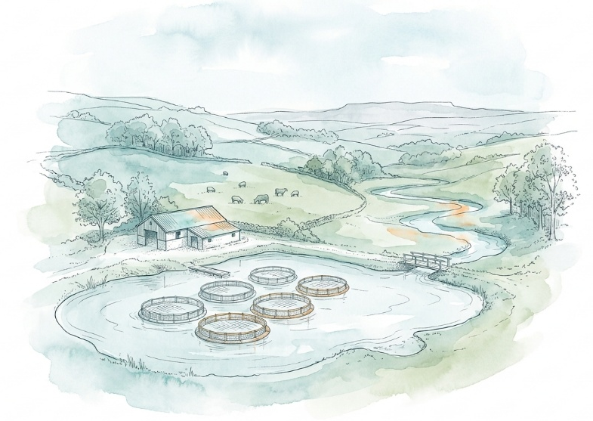
Low-flow pressure remained relevant in 2026. The Environment Agency’s August 2026 Yorkshire water situation report recorded notably low monthly mean flows across the western Pennine catchments, while reservoir levels continued to decline. The Aire and Calder received rainfall within the normal monthly range, but this did not by itself indicate recovery of river flows, reservoirs or aquatic habitats.
England-wide modelling projects ecologically significant warming in rivers to 2080. Warmer water generally contains less dissolved oxygen and can reduce the amount of suitable habitat available to cold-water fish.
Local evidence confirms that a range of fish populations and habitats are likely to be exposed. The West Yorkshire Local Nature Recovery Strategy identifies freshwater fish, including Atlantic salmon, brown or sea trout, bullhead, European eel and river lamprey, as a priority species group. Its water priorities cover habitat beside and between water bodies, aquatic habitat, catchments and floodplains. The spatial assessment of Nature Related Climate Risks in the West Yorkshire Combined Authority also provides a strategic regional spatial evidence base for selected nature-related assets.
The evidence available for this assessment did not allow fisheries, angling waters or inland aquaculture businesses to be mapped consistently across the five districts. It was not possible, therefore, to estimate the proportion of the fisheries and aquaculture system exposed to climate hazards. West Yorkshire’s fisheries and aquaculture are already exposed and this is likely to continue in the future. The risk has therefore been scored as moderate for exposure.

Sensitivity: How significant could this risk be for the West Yorkshire region?
Significant
Sensitivity
Fish populations are sensitive to changes in temperature, flow, oxygen, water quality and habitat connectivity. Hot, dry periods can reduce cool-water habitat and place fish under physiological stress. Floods and intense rainfall can disturb spawning habitat and carry sediment, nutrients and pollutants into rivers. Drought followed by heavy rainfall may be particularly damaging because accumulated pollutants can be washed into watercourses when aquatic ecosystems are already stressed.
Existing pressures increase sensitivity. Barriers such as weirs can restrict access to spawning grounds and cooler upstream refuges. The Environment Agency’s 2017-2018 Yorkshire fisheries report recorded fish-passage and habitat work on the Aire and at sites in Halifax, Dewsbury and elsewhere in Yorkshire. It also described pollution and parasite-related fish mortality incidents.
The consequences could include fish mortality, altered species composition, reduced breeding success, deterioration of recreational fisheries and loss of benefits associated with angling and healthy waterways. National evidence shows that freshwater angling has economic and social value, but the supplied survey provides England-wide figures and does not quantify West Yorkshire’s angling economy. Current local evidence is also too limited to identify the number of fisheries, businesses, jobs or livelihoods at risk. The Significant score therefore reflects potentially substantial effects on individual water bodies and fisheries, not evidence of catastrophic effects across the regional economy.

Adaptive Capacity: Existing programmes, plans, policies, budgets and community action
Moderate
Adaptive Capacity
Relevant strategies, regulation, technical skills, partnerships and practical programmes exist, although most address freshwater ecosystems and water management more broadly rather than fisheries or aquaculture as a distinct sector.
The West Yorkshire Local Nature Recovery Strategy⁸ provides a current regional framework. It identifies priorities for riparian habitat, aquatic habitat, connected catchments and floodplains, and freshwater fish. It supports river restoration, better connectivity, improved water quality and nature recovery across the water environment. However, its measures do not provide permission or guaranteed funding, and delivery depends on landowners, responsible authorities and ecological assessment.
Practical fish-passage capacity is well established. The Great Yorkshire Rivers Partnership brings together Yorkshire Water, the Environment Agency and The Rivers Trust to address artificial barriers in Yorkshire’s rivers, with an ambition to address all significant barriers by 2043. Since 2009 various groups, organisations, and partnership have successfully “opened-up” over 100 weirs in Yorkshire, including fish and eel passes on the River Aire and improvements to Hebble Brook in Halifax.
Drought planning also provides relevant capacity. Yorkshire Water’s current drought-plan explains that its plan is intended to maintain supplies while considering customers and the environment. The Draft Drought Plan 2027 monitoring appendix identifies sensitive fish receptors on the River Wharfe, including Atlantic salmon, brown trout, lamprey and grayling. It sets out baseline, in-drought and post-drought fisheries monitoring and possible mitigation measures such as flow adjustment, aeration, refuges, fish rescue, habitat enhancement and barrier modification. However, these provisions are associated with specified drought options and reaches, rather than being a comprehensive West Yorkshire fisheries adaptation programme.
Community and third-sector capacity is also present. Yorkshire Wildlife Trust coordinates monitoring, mapping, volunteer activity and management of invasive non-native species through the Yorkshire Invasive Species Forum and associated projects. West Yorkshire Ecology Service maintains the regional ecological record and provides biodiversity advice, offering an important evidence base for monitoring habitats and species.
Adaptive capacity is scored moderate rather than significant because current action is substantial but fragmented. Available evidence does not demonstrate a current inventory of fisheries and aquaculture assets, consistent monitoring of fish temperature and mortality, quantified programme coverage, or a dedicated regional fisheries climate-adaptation plan.

Annex: Scoring Matrix
The scoring methodology uses the following formula to calculate overall vulnerability for each risk/opportunity area.
Exposure
Sensitivity
Adaptive Capacity
Overall Vulnerability
Exposure, sensitivity and adaptive capacity are scored on a scale of 0-3 (see below).

Exposure
The presence of people, livelihoods, species or ecosystems, environmental functions, services, and resources, infrastructure, or economic, social, or cultural assets in places and settings that could be adversely affected.
Score | Rating | Description | Area or System exposed
3 | High | 50-100% of affected area/system expose to climate hazards | 50-100%
2 | Significant | 25-50% of affected area/system expose to climate hazards | 25-50%
1 | Moderate | 10-25% of affected area/system expose to climate hazards | 10-25%
0 | Low or None | 0-10% of affected area/system expose to climate hazards | 0-10%

Sensitivity
The degree to which a system or species is adversely or beneficially affected by climate variability or climate change.

Score | Rating | Description
3 | High sensitivity | Potential loss of life or high impact caused by climate change. Difficult or impossible for systems to recover
2 | Significant sensitivity | If climate changes event happens, high impact, but not catastrophic
1 | Moderate sensitivity | If climate changes event happens, there is an impact, but not very disruptive
0 | None or low sensitivity | Limited or no consequence from climate event

Adaptive Capacity
The ability of current systems, institutions, structural units, humans and other organisms to adjust to potential damage, to take advantage of opportunities, or to respond to consequences
Score | Rating | Description
0 | Low or No Adaptive Capacity | Limited or no local or national policies or programmes in place to currently address specific risk/opportunity
1 | Moderate Adaptive Capacity | Either some local or national policies and programmes in place, that may indirectly address risk/opportunity or are limited in scope
2 | Significant Adaptive Capacity | Either local or national policies and programmes in place specifically addressing risk, but there are still gaps
3 | High Adaptive Capacity | Well established systems (policies, programmes) that are currently addressing this risk

Vulnerability
The final vulnerability score is calculated by adding the exposure and sensitivity scores, then subtracting the adaptive capacity score. Vulnerability is then categorised from Very High to Very Low depending on the final score.
Score | Rating
Very High | Total Score between 5 & 6
High | Total Score between 3 & 4
Medium | Total Score between 1 & 2
Low | Total Score between -1 & 0
Very Low | Total Score between -3 & -2

The detailed scoring matrix is provided in Annex: Scoring Matrix.
Local Authority Climate Report | West Yorkshire
Chapter 5: Land, Nature, and Food - UK Climate Risk
West Yorkshire Natural Environment Stakeholder Focus Group, 9 September 2026, facilitated for the West Yorkshire Climate Risk Assessment
2025 Drought, How It Developed in England | Environment Agency (2026)
Yorkshire Water Situation Report August 2026
Water Temperature Projections for England's Rivers | Environment Agency (2025)
West Yorkshire Local Nature Recovery Strategy (2026)
Nature Related Climate Risk Exposure in the West Yorkshire Combined Authority (2026)
Annual Fisheries Report 2017 to 2018 Yorkshire | Environment Agency
A survey of freshwater angling in England | Environment Agency (2018)
Great Yorkshire Rivers Partnership
Fish passage and artificial barrier removal in Yorkshire (2023)
Yorkshire Water Draft Drought Plan 2027
Draft Drought Plan 2027: Updated Environmental Monitoring Plan
Tackling Invasive Species | Yorkshire Wildlife Trust
West Yorkshire Ecology Service

