N8: Risks to forestry for West Yorkshire

Summary vulnerability assessment
This report forms part of the West Yorkshire Combined Authority Climate Risk and Vulnerability Assessment and examines risks to forestry. Woodland occurs across all five West Yorkshire districts and faces growing pressures from drought, heat, wildfire, storms, flooding, waterlogging, pests and diseases. The assessment rates exposure as high and sensitivity as significant because climate change could cause tree mortality, failed establishment and reduced growth, while weakening timber value, carbon storage, biodiversity, recreation, urban cooling, flood management and soil protection. Existing strategies, partnerships, guidance and local programmes provide significant adaptive capacity, but woodland management, specialist skills, long-term funding, monitoring and evidence of adaptation uptake remain insufficient for the scale and pace of projected change.
The resulting overall vulnerability rating is high. The figure below summarises the assessment scores for exposure, sensitivity, adaptive capacity and overall vulnerability.
3
High
2
Significant
2
Significant
3
High
Exposure
Sensitivity
Adaptive Capacity
Overall Vulnerability

Risk summary
Climate change is already affecting forests and woodlands through drought, heat, wildfire, storms, flooding, waterlogging, pests and diseases. These pressures can interact. For example, drought can weaken trees, making them more susceptible to pests, while disease and storm damage can add dry fuel and increase wildfire risk. The national assessment rates the risk to forestry in England as High now and through the 2050s, rising to Very high by the 2080s, with more action needed. It also identifies important gaps in understanding compound risks and the uptake and effectiveness of adaptation measures. For West Yorkshire, the risk applies to commercial and community woodland, ancient woodland, newly planted sites and trees in parks, streets, river corridors and the wider landscape. Damage could affect timber, carbon storage, biodiversity and recreation, as well as the role woodland plays in cooling, flood management, air quality and soil protection.

Exposure: How exposed is West Yorkshire Combined Authority to this risk?
High
Exposure
Woodland occurs across all five West Yorkshire districts. A separate assessment based on the National Forest Inventory records 17,315 hectares of woodland in the West Yorkshire Combine Authority, of which 12,900 hectares, or 74.5%, is broadleaved woodland and 1,671 hectares, or 9.65%, is conifer woodland (See Figure 1). Larger and more connected areas occur mainly along the western uplands and valleys of Calderdale, Bradford and Kirklees. Woodland in Leeds and Wakefield is generally more dispersed, including smaller sites around settlements and urban fringes (see Figure 2).
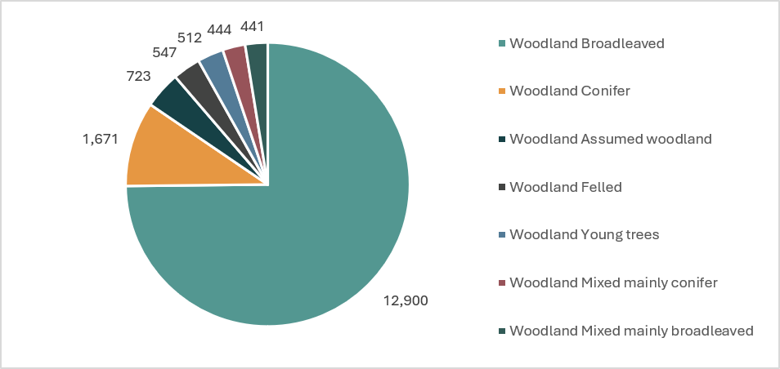
Figure 1: Area of woodland in West Yorkshire by National Forest Inventory woodland type
All woodland could experience at least one relevant climate pressure, but the dominant hazards and severity will vary by location, soil, age, species, structure and management. Upland and exposed woodland may face greater wind risk. Young or recently planted trees are particularly vulnerable to drought and fire. Woodland on poorly drained or floodplain soils may face waterlogging. Sites beside moorland or other combustible habitats may be exposed to fires that begin outside the woodland. National guidance confirms that risk must be assessed at site level rather than inferred from woodland type alone.

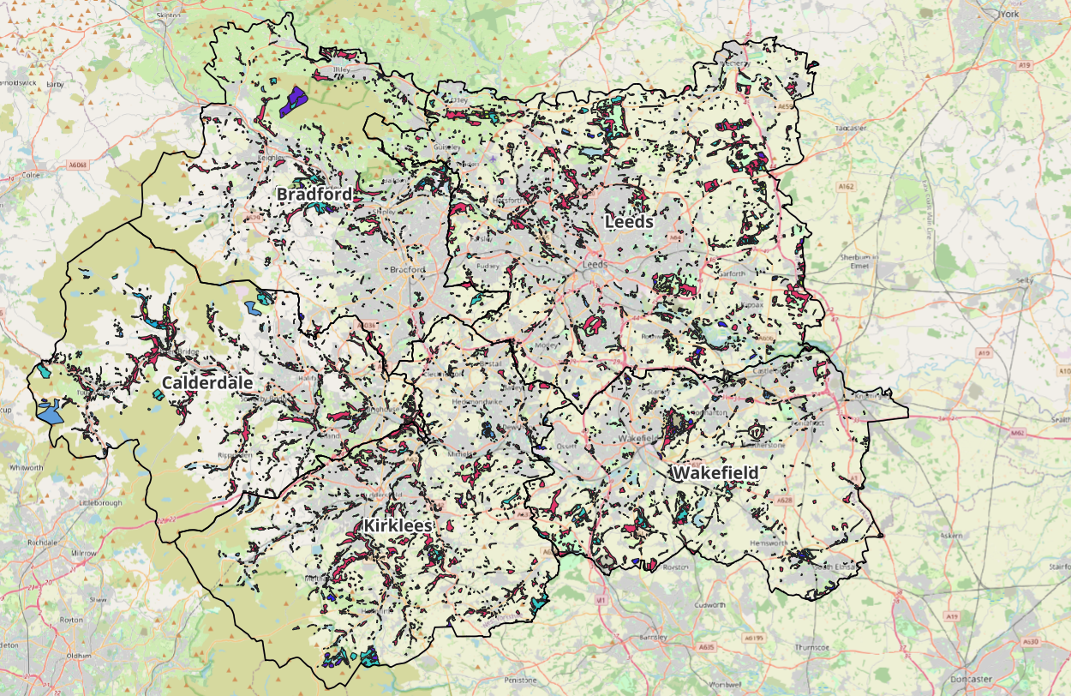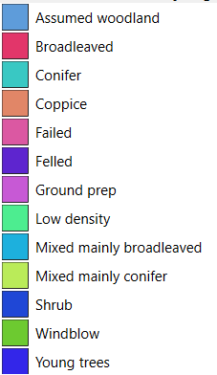
Figure 2: Distribution of woodland in West Yorkshire by National Forest Inventory woodland type

Local evidence supports exposure to several climate hazards. Forestry sector interviewees identified drought and wildfire as prominent recent concerns in West Yorkshire, and also highlighted wind exposure in upland areas. They reported instances where fires had spread through recently created woodland.
Natural-environment stakeholders also reported drought pressure on trees, windblown trees, drought-related limb drop and changing planting seasons. Their evidence to this assessment covered woodland and urban trees but did not provide a systematic inventory, species profile or condition assessment across the five districts.
The score of High is therefore based on the region-wide distribution of woodland and the breadth of relevant hazards. It does not mean that every woodland is currently experiencing severe damage. Local data do not yet show the percentage of woodland exposed to each individual hazard or identify the most vulnerable stands consistently.

Sensitivity: How significant could this risk be for the West Yorkshire region?
Significant
Sensitivity
Climate impacts could cause substantial tree mortality, failed establishment, reduced growth, loss of timber value and higher management and replacement costs. Severe or repeated damage could also weaken biodiversity, carbon storage, landscape character, recreation, urban cooling, flood management and soil protection. The consequences are likely to be significant but are not expected to be catastrophic across the entire regional woodland system.
Sensitivity is increased by existing fragmentation, under-management, young planting, unsuitable tree or planting-material choices, limited diversity and exposure to several hazards in sequence. The West Yorkshire Local Nature Recovery Strategy reports that approximately 62% of West Yorkshire woodland is unmanaged. It identifies sustainable management, habitat connectivity and long-term resilience as important opportunities.
Forestry sector stakeholders warned that climate change and pests are narrowing the range of tree species suitable for some sites. They also noted that drought-stressed trees may become more susceptible to attack.⁷ Site characteristics remain critical, and adaptation choices need to consider what trees are expected to deliver rather than relying only on whether a species is locally native.
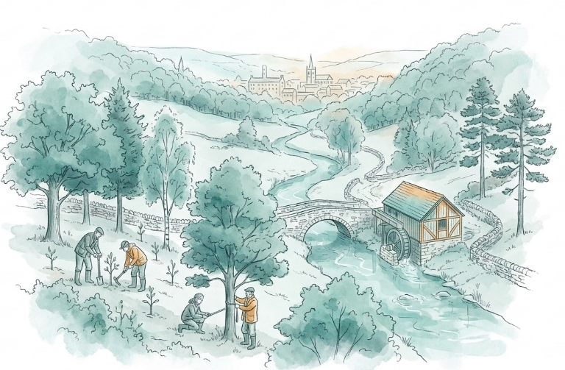
The mainly broadleaved regional forestry resource may be less exposed to some wildfire pathways than young conifer plantations, but it should not be characterised as low risk overall. National guidance states that young broadleaved planting can still suffer substantial fire damage where combustible ground vegetation is present.⁶ Broadleaved woodland also remains susceptible to drought, storms, disease and waterlogging.
Sensitivity is also heightened by the time required to replace mature woodland functions. Trees planted now must establish under current conditions and remain suitable over much warmer future decades. Damage may therefore lock in losses or compromise expected benefits for long periods. However, the available West Yorkshire evidence does not quantify woodland condition, age structure, species diversity, drought mortality, disease prevalence, timber production or economic dependence consistently across the region. This uncertainty supports a Significant, rather than High, score.

Adaptive Capacity: Existing programmes, plans, policies, budgets and community action
Significant
Adaptive Capacity
West Yorkshire has a strong strategic framework, an established regional partnership, national guidance and active local programmes. However, gaps remain in woodland management, specialist skills, secure long-term funding, monitoring and evidence of adaptation uptake.
The White Rose Forest Strategic Plan 2025-2050 is the overarching tree and woodland strategy for North and West Yorkshire. It aims to improve resilience to pests, disease and climate change; increase sustainably managed woodland from 62% to 70%; and bring an additional 7,250 hectares of woodland into sustainable management across its full North and West Yorkshire geography. It also includes targets for tree cover, community involvement, accessible woodland and non-public finance.
The White Rose Forest Action Plan 2026-2031adds actions on woodland establishment, sustainable management, public engagement, policy alignment and fundraising. It proposes piloting the Restore programme, supporting ancient-woodland condition assessment and monitoring, developing skills and capacity, and strengthening access to markets and finance. The plan reports that the preceding 2021-25 programme attracted £27.5 million and planted approximately three million trees across North and West Yorkshire. It also makes clear that future delivery depends on confirmed funding, additional income, core-team capacity and partner support.
The West Yorkshire Local Nature Recovery Strategy provides regional priorities for ancient and veteran trees, other woodlands and wood pasture^{.9} It supports increased canopy cover, sustainable management, woodland connectivity and the protection and restoration of important woodland habitats. However, it is a strategic framework rather than a funded delivery plan.
The West Yorkshire Climate and Environment Plan 2025-2038 records support for tree planting through White Rose Forest and Green Streets, alongside wider nature-recovery partnerships. It provides regional policy alignment, but the evidence reviewed does not isolate a forestry-adaptation budget or show how much of the supported planting is being designed and managed specifically for future climate resilience.
At district level, current evidence shows further capacity, including urban woodlands:
- Leeds has a woodland-creation programme involving community planting, schools and locally grown planting material. Its published programme proposes 1,250 hectares of additional woodland over 25 years and describes the use of native broadleaves and other resilient species.
- Bradford maintains public trees and woodland, undertakes professional inspections and operates an emergency response for failed trees. Its published information also describes woodland management and replacement planting, but identifies budget constraints that prioritise statutory safety work.
Significant national capacity, guidance and tools exist, including an adaptation practice guide, climate matching tool, ecological site classification and a structured resilience framework.
The Forestry Commission’s fourth adaptation report provides further national context. It records progress in standards, guidance, decision-support tools, training and planting-stock support, but also identifies continued reliance on a limited number of tree species and even-aged structures, shortages of forestry skills, limited incentives for wider silvicultural systems, and a lack of tree-species-specific establishment-success data for most woodland-creation schemes. These are England-wide findings rather than a direct measure of West Yorkshire capacity, but they reinforce the need to assess whether local planting and management programmes are delivering diverse, climate-resilient woodland in practice.
The main limitation to adaptive capacity in West Yorkshire is likely to be delivery at scale. Stakeholders identified finance, staff time, landowner engagement, coordination and repeated extreme events as constraints.⁸ Forestry sector interviewees also stressed that woodland policies commonly assume trees will deliver climate benefits without adequately planning for the resilience of the woodland itself.⁷ Evidence does not show consistent uptake of adaptation guidance, management plans or decision-support tools across West Yorkshire.

Annex: Scoring Matrix
The scoring methodology uses the following formula to calculate overall vulnerability for each risk/opportunity area.
Exposure
Sensitivity
Adaptive Capacity
Overall Vulnerability
Exposure, sensitivity and adaptive capacity are scored on a scale of 0-3 (see below).

Exposure
The presence of people, livelihoods, species or ecosystems, environmental functions, services, and resources, infrastructure, or economic, social, or cultural assets in places and settings that could be adversely affected.
Score | Rating | Description | Area or System exposed
3 | High | 50-100% of affected area/system expose to climate hazards | 50-100%
2 | Significant | 25-50% of affected area/system expose to climate hazards | 25-50%
1 | Moderate | 10-25% of affected area/system expose to climate hazards | 10-25%
0 | Low or None | 0-10% of affected area/system expose to climate hazards | 0-10%

Sensitivity
The degree to which a system or species is adversely or beneficially affected by climate variability or climate change.

Score | Rating | Description
3 | High sensitivity | Potential loss of life or high impact caused by climate change. Difficult or impossible for systems to recover
2 | Significant sensitivity | If climate changes event happens, high impact, but not catastrophic
1 | Moderate sensitivity | If climate changes event happens, there is an impact, but not very disruptive
0 | None or low sensitivity | Limited or no consequence from climate event

Adaptive Capacity
The ability of current systems, institutions, structural units, humans and other organisms to adjust to potential damage, to take advantage of opportunities, or to respond to consequences
Score | Rating | Description
0 | Low or No Adaptive Capacity | Limited or no local or national policies or programmes in place to currently address specific risk/opportunity
1 | Moderate Adaptive Capacity | Either some local or national policies and programmes in place, that may indirectly address risk/opportunity or are limited in scope
2 | Significant Adaptive Capacity | Either local or national policies and programmes in place specifically addressing risk, but there are still gaps
3 | High Adaptive Capacity | Well established systems (policies, programmes) that are currently addressing this risk

Vulnerability
The final vulnerability score is calculated by adding the exposure and sensitivity scores, then subtracting the adaptive capacity score. Vulnerability is then categorised from Very High to Very Low depending on the final score.
Score | Rating
Very High | Total Score between 5 & 6
High | Total Score between 3 & 4
Medium | Total Score between 1 & 2
Low | Total Score between -1 & 0
Very Low | Total Score between -3 & -2

The detailed scoring matrix is provided in Annex: Scoring Matrix.
Chapter 5: Land, Nature, and Food - UK Climate Risk
National Forest Inventory England 2023
Nature Related Climate Risk Exposure in the West Yorkshire Combined Authority (2026)
Local Authority Climate Report | West Yorkshire
Adapting forest and woodland management to the changing climate | UK Forestry Standard Practice Guide (2022)
Key stakeholder interview 24 August 2026, facilitated for the West Yorkshire Climate Risk Assessment
West Yorkshire Natural Environment Stakeholder Focus Group, 9 September 2026, facilitated for the West Yorkshire Climate Risk Assessment
West Yorkshire Local Nature Recovery Strategy (2026)
White Rose Forest Strategic Plan 2025-2050
White Rose Forest Action Plan 2026-2031
West Yorkshire Climate and Environment Plan 2025-2038
Woodland Creation | Leeds City Council
Trees and woodland on public land | Bradford City Council
UK Forestry Standard Adaptation Guide
Climate Matching Tool
Ecological Site Classification
Resilience Implementation Framework
Climate change adaptation reporting fourth round: Forestry Commission (2025)

